Re-Costing the
Child Justice Bill
Updating the original costing taking into consideration changes made to the bill

May 2001
By:

Conrad Barberton and John Stuart
Economist Economist
with AFReC (Pty) Ltd. with AFReC (Pty) Ltd
a consulting company affiliated to the University of Cape Town

Contact Details:

Tel: 021 6502719
021 650 4443
Fax: 021 686 9575
Email: cbarbert@commerce.uct.ac.za

New Acknowledgements
We would like to thank Ann Skelton, Project Co-ordinator of the Child Justice Project, for her confidence in our previous costing of the Child Justice Bill, and consequently for commissioning AFReC (Pty) Ltd to re-cost the Bill taking into consideration the changes made to the Bill since the previous costing was undertaken. We also thank Professor Julia Sloth-Nielson of the Law Faculty, UWC, for assistance with assumptions again. Given that this project builds on that previous costing it is appropriate that we thank all those that were involved in that project again (see original Acknowledgements below).

In addition to these people we would like to thank Dr Tertius Geldenhuys for very useful input regarding the role of police in the child justice system.

We thank the Child Justice Project for providing funding for the project. The Child Justice Project is a United Nations Technical Assistance Project of the Government of South Africa, and is located in the Directorate of Children and Youth Affairs: Department of Justice. The project arises from an agreement between the Government, the UNDP, the CICP and UNOPS. The project is funded by the Swiss Development Co-operation and the UNDP.

Original Acknowledgements

A project of this nature is dependent on the co-operation and input of a large number of people in various government departments, NGOs and academic institutions. We would like to thank all those that willingly gave of their time to supply information and insights regarding the functioning of the existing criminal justice system and the likely impact of the Child Justice Bill. The names of all the people who contributed in one way or another are noted in the List of Interviews. Our thanks to each one, and our sincere apologies in the event of any omission.

We owe a particular debt to Professor Julia Sloth-Nielson of the Community Law Centre, UWC, for numerous meetings around the structure of the CJ-model and the assumptions underlying the different scenarios, as well as for her valuable input on previous drafts.

Our thanks also to Ann Skelton, Project Leader of the Juvenile Justice Project of the South African Law Commission, both for giving us the opportunity to work on this exciting project and for her insights on the functioning of the Bill.

We thank SIDA for providing the funding for the project.

The Research Team

Project leader: Conrad Barberton, B.A. (Stellenbosch), B.A. (Hons.) (Economics) (Rhodes), M.A. (Economics) (Stellenbosch), M.Phil (Economics) (Cambridge)

Modeller: John Stuart, B.Com.; B.Com. (Hons.) (Economics); M.Com. (Economics) (Natal)

Executive Summary
The Child Justice Bill will make significant changes to the way children in conflict with the law are managed within the criminal justice system. The two most significant changes proposed are the introduction of the preliminary inquiry and the wider use of diversion and alternative sentencing. Other important elements seek to look after children’s interests by addressing issues relating to the arrest, detention, assessment, diversion, legal representation, trial and sentencing of children. The Bill also proposes to set up a system for monitoring child justice. The overall aim of the Bill is to introduce an explicit restorative justice focus to the way children in conflict with the law are treated by the criminal justice system.

This report seeks to evaluate the cost of implementing the Child Justice Bill. As far as can be determined this is the first time in South Africa that a Bill will have been costed prior to it being tabled in Parliament. Ideally all bills should be costed before being tabled.

The costing method used in this report is best described as a variant of cost-effectiveness analysis, as it explores and compares the cost-effectiveness of the way children are currently processed by the existing criminal justice system with the system described in the Child Justice Bill. A spreadsheet model, referred to as the CJ-model, was built to map the flow of children through the different stages of the current and new systems. Starting from the total number of alleged offences involving children between 7 and 18 years old, it estimates the number of children arrested, referred to assessment, diverted, brought to trail, sentenced and so forth. It also indicates how and when children leave the system. The model calculates the cost associated with processing, transporting, and detaining children arriving at each of the stages in the system during the course of a year, taking into consideration the different levels of criminality in metropolitan, urban and rural areas.

To compare the cost of the current child justice system with that proposed by the Child Justice Bill, three scenarios were generated and run in the CJ-model. The ‘baseline’ scenario seeks to replicate the flow of children through the current criminal justice system as closely as possible. It therefore does not include the preliminary inquiry process. The ‘full’ scenario seeks to replicate the flow of children through the new child justice system described in the Child Justice Bill. It therefore incorporates the preliminary inquiry, increased use of diversion and alternative sentences. It is an ideal scenario. The ‘rollout’ scenario seeks to replicate how the new child justice system is likely to function at about the halfway point in the process of implementation. In other words the basic elements of the new system are assumed to be in place, but they are not being uniformly applied. Running these three scenarios on the CJ-model generates information on the expected process outputs of the existing and new child justice systems (e.g. the number of children likely to be diverted or sentenced to prison), and, very importantly, the likely expenditure at each stage of the child justice system for each scenario. Comparing this information across the scenarios enables us to evaluate likely savings or increased expenditures and therefore the relative cost-effectiveness of the current child justice system and that proposed by the Child Justice Bill.

Using the baseline scenario, it is estimated that the government currently spends about R787 million per year on dealing with children in conflict with the law. The full scenario suggests that the implementation of the child justice system proposed by the Child Justice Bill could reduce this to about R607 million per year. This implies a saving of about R180 million per year on current levels of expenditure or an annual saving of over 20 percent. Closer analysis of the results suggests that implementing the Child Justice Bill will enable the Department of Correctional Services to realise substantial savings on its current levels of expenditure on the child justice system. The Department of Justice and Constitutional Development is likely to realise a modest saving on the magistrates’ and prosecutors’ time required by the child justice system. The Department of Justice is likely to realise a slightly more substantial saving on legal representation due to the decreased number of children going to trial. The Department of Safety and Security will probably need to spend substantially more on the new child justice system than they currently spend on children in conflict with the law. The provincial welfare departments will also need to increase their expenditure on diversion, the provision of places of safety and secure care facilities. Overall, however, government stands to realise substantial savings as shown in the figure below.

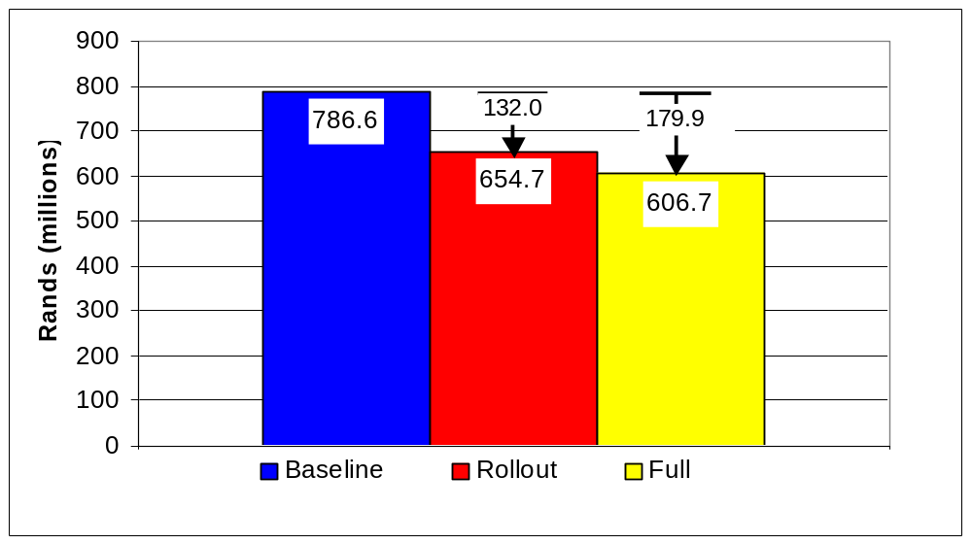
Total annual cost of each scenario of the child justice system

However, what the report also shows is that in order to realise these savings there needs to be a substantial reallocation of resources from existing activities to assessment services, the preliminary inquiry process and the provision of diversion and alternative sentencing options. The Department of Justice’s role in this reallocation of resources is critical. Sufficient magisterial time needs to be made available to the preliminary inquiry to ensure that it succeeds in its objective to divert the maximum number of children from the court system, while at the same time ensuring that both the interests of society and the interests of children in conflict with the law are served. The provincial welfare departments also have a critical role to play to ensure adequate funding is made available for the provision of diversion. It is proposed that a conditional grant from national government should be used to enable provincial welfare departments to phase-in the changes into their budgets.

It needs to be emphasised that the savings quantified in this research are only a small part of the overall benefits that will accrue from the implementation of the Child Justice Bill. The importance of keeping children out of prisons so as to break the cycle of crime cannot be overemphasised. Other research has shown that recidivism rates are very low for children that have participated in existing diversion programmes. It is also possible that reducing the flow of cases involving children to the court system will significantly reduce the pressure on the system. This will enable it to deal with existing backlogs and ensure a more efficient and effective service generally. The positive spin-off effects of this for the entire criminal justice system and for society as whole will be very substantial.

Probably the most outstanding aspect of the new child justice system proposed by the Child Justice Bill is that it will not only enable the government to realise substantial savings, but also ensure that the remaining expenditure is spent more effectively. This is highlighted by the fact that instead of sending 14 200 to prison each year at a cost of R431 million, the new system will direct 60 000 children towards restorative justice programmes at a cost of a little over R29 million, and in the process enable the government to effect overall savings of about R180 million.

Table of Contents
New Acknowledgements i
Original Acknowledgements i
The Research Team i
Executive Summary ii
Table of Contents v
List of Tables vii
List of Figures viii
1 Introduction to re-costing the Child Justice Bill 1
1.1 The Public Finance Management Act and costing legislation 2
1.2 Methodology 3
1.3 Information gathering and consultations 3
1.4 Economic analysis of policy initiatives 4
2 Modelling the Child Justice Bill 6
2.1 Data availability and weaknesses 6
2.2 The CJ-model 7
2.3 Variables used in the CJ-model 10
2.4 The division into metropolitan, urban and rural areas 10
2.5 Three scenarios for costing the Child Justice Bill 11
2.6 Number of children entering the criminal justice system 12
2.6.1 Age and criminal capacity 13
2.6.2 Breakdown of cases by crime category 14
3 Discussion of results: comparing the three scenarios 15
3.1 Overall process outcomes 15
3.1.1 The flow of cases through the child justice system 15
3.1.2 The use of diversion and alternative sentencing options 16
3.1.3 Children given residential sentences (reform school and prison) 16
3.1.4 Children held in detention 17
3.2 Overall cost outcomes 20
3.2.1 Total annual cost of the child justice system 20
3.2.2 Breakdown of costs according to stage 21
3.2.3 Allocation of costs to different expenditure items 23
3.3 Impact of wider use of One-Stop Child Justice Centres 24
3.3.1 Cost of police detention vs rapid assessment 24
3.3.2 The more effective use of alternative residential/detention facilities 25
3.4 Impact of introducing the preliminary inquiry 26
3.4.1 Savings in total court costs due to use of preliminary inquiry 27
3.4.2 Impact on number of cases involving children brought before the court 29
3.4.3 Impact on backlogs in the court system 29
3.4.4 Children held in detention 30
3.5 Impact of wider use of diversion/alternative sentencing options 30
3.5.1 Cost of diversion versus cost of residential sentences 30
3.5.2 The trade-off between diversion costs and residential sentence costs 31
3.6 Transport costs 33
3.7 Cost of legal representation 34
3.8 Cost of monitoring the child justice system 35
3.9 Training costs 36
4 Impact on intergovernmental finances and departmental budgets 38
4.1 Impact on intergovernmental finances 38
4.1.1 Impact on the intergovernmental division of revenue 38
4.1.2 The risk of unfunded mandates on provinces 40
4.2 Impact on departmental budgets 43
4.2.1 Department of Justice and Constitutional Development 43
4.2.2 Department of Correctional Services 45
4.2.3 Department of Safety and Security 47
4.2.4 Department of Social Development and provincial welfare departments 50
4.2.5 Provincial education departments 54
5 Implementation Strategy 55
5.1 Political and managerial buy-in 55
5.2 A systemic approach 55
5.3 Big bang’ vs ‘Roll-out’ 56
5.4 Developing capacity 57
5.5 Ensuring effective monitoring 57
5.6 Focussing on areas of maximum impact 58
5.6.1 One-Stop Justice Centres 58
5.6.2 Operational clusters 59
5.6.3 Location of One-Stop Justice Centres and other facilities for maximum impact 59
5.6.4 Court jurisdictions 59
5.7 Purchasing diversion services 60
5.8 Financing reform schools 60
5.9 Capital costs of implementation 61
6 Conclusion 62
7 References 63
8 List of interviews 65

List of Tables

Table 1: Criteria used to allocate magisterial districts to categories 11
Table 2: Children between 7 and 18 years living in different areas 11
Table 3: Number of children entering the criminal justice system per year 13
Table 4: Initial breakdown of cases by crime category 14
Table 5: Breakdown of annual costs by stage for each scenario 22
Table 6: Annual number of children admitted to detention/holding facilities in Stages 1 and 2 26
Table 7: Magistrates and prosecutors hours in the different scenarios 27
Table 8: Annual number of cases arriving at different stages in the child justice system 29
Table 9: Unit cost of different diversion and sentencing options 31
Table 10: Annual number of children diverted versus various sentencing options 32
Table 11: Estimated annual cost of legal representation in Stage 5 of each scenario 34
Table 12: Proposed staff structure of monitoring system 35
Table 13: Annual cost of monitoring the child justice system 36
Table 14: Estimated number of people to be trained 36
Table 15: Estimated cost of three-year training programme 37
Table 16: Total annual expenditure on the child justice system by sphere of government and by department 38
Table 17: Percentage breakdown of expenditure between spheres of government 39
Table 18: Potential annual saving for each sphere of government 39
Table 19: Breakdown of annual expenditure on welfare by province 53
Table 20: Estimated annual expenditure on reform schools by scenario 54

List of Figures
Figure 1: Where to use cost-benefit and cost-effectiveness analysis 5
Figure 2: The child justice system as modelled by the CJ-model 9
Figure 3: Annual number of cases remaining in the child justice system at the end of each stage 15
Figure 4: Total number of children diverted each year 16
Figure 5: Total number of children given residential sentences each year 17
Figure 6: Total number of days children are held in detention each year 18
Figure 7: Total number of days children held in places of safety and secure care each year 19
Figure 8: Total annual cost of each scenario of the child justice system 21
Figure 9: Allocation of annual costs to different expenditure items in each scenario 23
Figure 10: Annual cost of police detention after arrest versus annual cost of rapid assessment 25
Figure 11: Number of days children spend in residential/detention facilities in Stages 1 and 2 26
Figure 12: Annual cost of preliminary inquiry (Stage 4) and total court costs (Stages 5, 6 and 7) 28
Figure 13: Annual cost of diversion versus annual cost of residential sentences 32
Figure 14: Annual cost of transport at different stages in the child justice system 33
Figure 15: Total annual expenditure by the Department of Justice on the child justice system in each scenario 43
Figure 16: Annual expenditure by the Department of Justice by stage for each scenario 44
Figure 17: Total annual expenditure by the Department of Correctional Services on the child justice system in each scenario 45
Figure 18: Annual expenditure by the Department of Correctional Services by stage for each scenario 46
Figure 19: Total annual expenditure by the Department of Safety and Security on the child justice system in each scenario 47
Figure 20: Annual expenditure by the Department of Safety and Security by stage for each scenario 48
Figure 21: Total annual expenditure by national and provincial welfare departments on the child justice system in each scenario 50
Figure 22: Total annual expenditure by the provincial departments of welfare on the child justice system in each scenario 52
Figure 23: Annual expenditure by provincial welfare departments by stage for each scenario 52

Introduction to re-costing the Child Justice Bill
The first costing of the Child Justice Bill was of a draft bill released for comment by the South African Law Commission's Project Committee on Juvenile Justice in December 1998. The results of this first costing were reported to the Juvenile Justice Committee of the South African Law Commission (who commissioned the research) and were also published in Costing the Implementation of the Child Justice Bill & Developing a Strategy for Implementation, Monograph No.14 (November 1999) in the AFReC (UCT) Monograph Series. These costing results have also been presented in a number of other forums, including as a paper to the 14^{tth} International Conference of the International Society for the Reform of Criminal Law which was held in Sandton from 3 to 7 December 2000.

Subsequent to the costing, and in certain instances as a result of the costing, various changes were made to this draft Child Justice Bill. These changes obviously mean that the likely cost of implementing the (revised) Child Justice Bill will differ to a greater or lesser extent from the version of the bill that the original costing was based on. In the light of this Ann Skelton, Co-ordinator of the UNDP Child Justice Project, decided to commission the team that did the original costing to re-cost the Child Justice Bill.

The aim of this re-costing project is threefold:
- To adjust the original costing model to take into account the changes that have been incorporated in the draft of the Child Justice Bill published in the South African Law Commission’s report on Juvenile Justice (Project 106), which was submitted to the Minister of Justice and Constitutional Development in July 2000, as well as refinements to the costing model and data suggested by various interested parties;
- To re-cost the different implementation scenarios and to analyse the implications of the results for national and provincial departmental budgets; and
- To recommend actions that government can take to facilitate the implementation of the Bill when it is enacted.

This project therefore builds on the previous costing project. The methodology used is the same. The basic process data (for instance on the number of children arrested by the police) is much the same due to the fact that more recent data is not available, partly due to the government moratorium on crime statistics. However, input costs have been adjusted upwards in line with the latest information available (where such information could not be obtained the original costs have been increased by the average inflation rate for 2000). So this re-costing reflects, as far as is practical, the cost of implementing the (revised) Child Justice Bill at the beginning of 2001.

It is important to note that the results of this re-costing are not comparable to the results of the original costing project for two reasons:
- There are some important process differences between the drafts of the bills; and
- The input cost data between the two costing exercises differs.

As noted in the original costing report, the Child Justice Bill will make significant changes to the way children in conflict with the law are managed within the criminal justice system. The two most significant changes being proposed are the introduction of the preliminary inquiry and the wider use of diversion and alternative sentencing. Other important elements seek to look after children’s interests by addressing issues relating to the arrest, detention, assessment, diversion, legal representation, trial and sentencing of children. The Bill also proposes to set up a system for monitoring child justice. The overall aim of the Bill is to introduce an explicit restorative justice focus to the way children in conflict with the law are treated by the criminal justice system.

It needs to be noted up front that the CJ-model focuses on costing those elements of the proposed Bill that are intended to be mandatory such as assessment, the preliminary inquiry, legal representation and diversion. The model also focuses, primarily, on establishing the current cost of operating the new system as opposed to the capital cost of setting the system up. The model, therefore, does not capture the full implementation costs of the Bill. In addition, certain elements of the Bill are treated as setting out goals for the further development of the child justice system to be realised progressively, as resources become available. These are not costed by the model.

The Public Finance Management Act and costing legislation
Since the original costing of the Child Justice Bill was done, the Public Finance Management Act No.1 of 1999 (PFMA) has come into operation. Section 35 of the PFMA deals with unfunded mandates and reads as follows:

Draft national legislation that assigns an additional function or power to, or imposes any other obligation on, a provincial government, must, in a memorandum that must be introduced in Parliament with that legislation, give a projection of the financial implications of that function, power or obligation to the province.

The Child Justice Bill does impose certain obligations on provincial education and provincial welfare departments and therefore a memorandum giving a projection of the financial implications of the bill to the provinces needs to be introduced with the bill when it is tabled in Parliament. It is envisaged that the information derived from this costing exercise will assist the Department of Justice and Constitutional Development to compile the requisite memorandum.

In our view all the financial implications of all proposed legislation should be established and be made known to Parliament, and not only national legislation that has financial implications for provinces. This will help ensure that when Parliament passes legislation it also undertakes to vote the necessary funds to implement it, and thus avoid the unacceptable situation of legislation not being properly implemented because the cost of implementation was not factored into the medium term expenditure plans of the responsible departments. In the recent past numerous pieces of ‘good’ legislation have suffered this fate, most notably the Domestic Violence Act.

It is hoped that by doing a thorough costing of the Child Justice Bill at this stage, all the departments involved in its implementation will factor in the necessary changes to the their programmes and budgets to ensure rapid and effective implementation after the bill is passed by Parliament.

Methodology
The methodology used to develop the CJ-model is described in the terms of reference for the original costing project, which can be found in Annex 5. Very briefly, the methodology involved:

1. Mapping the flow of children through the current and new child justice systems and gathering information relating to the processing of children through different stages of the system.
2. Building a costing model which reflects the structure of both the current and the new child justice systems, and developing ‘baseline’, ‘rollout’ and ‘full’ implementation scenarios for comparing costs and other outcomes (see section 2.5).
3. Analysing the results derived from running different scenarios through the costing model and writing the report.

To update the original costing model we did a thorough comparative analysis of the earlier and later drafts of the Child Justice Bill, identifying those areas that had changed, and then incorporating the changes into the costing model. We also evaluated the comments/criticisms we had received on the original costing and, where appropriate, made suitable changes to the model or to the assumptions. Generally speaking, we made four types of changes to the original model:

- Process changes in the way children are dealt with by the child justice system (for instance the latest version of the Child Justice Bill requires that children remanded to places of safety and secure care facilities must appear every 60 days, or if remanded to a prison, appear every 30 days before the court, as opposed to every 14 days in both instances in the previous draft of the Bill);
- Making refinements to certain existing processes so as to more accurately reflect actual practice (for instance the time police take to deal with children in metropolitan, urban and rural contexts were differentiated to take into consideration the different times involved in transporting children – this followed discussions with an official from the Department of Safety and Security);
- Changes in process assumptions (for instance reducing the number of children being referred directly to assessment after arrest on the basis of information from an official in the Department of Safety and Security); and
- Updating of the input cost assumptions (as already mentioned).

As before the recommendations regarding implementation are based on the project team’s research on budget and financial management reform and experience with transformation projects in the public sector, informed by the results of this costing exercise

Information gathering and consultations
For the original costing project, an extensive information gathering exercise was undertaken to develop a thorough understanding of the functioning of the current child justice system and the implications of the changes being proposed by the Child Justice Bill. In the first instance, this involved gathering documentary information regarding the functioning of the system. A list of documents used or consulted in the course of the project is given in the references. In the second instance, information on the functioning of the system was gathered by way of semi-structured consultations with a wide-range of people involved with the child justice system. These include consultations with national and provincial/regional representatives of the departments of Safety and Security, Justice, Correctional Services and Welfare, with NGO’s such as NICRO and the Community Law Centre, and with individuals. A list of people who participated in these consultations is presented in the list of interviews.

For the purposes of this re-costing exercise our consultations were obviously far more restricted since we were not approaching the problem de novo, but rather building on an existing body of information.

Economic analysis of policy initiatives
Economic modelling is widely used by economists to explore the implications of different courses of action or the relationships between different variables within or impacting upon a given system. Two common approaches to evaluating new initiatives are cost-benefit analysis and cost-effectiveness analysis. As Figure 1 shows these approaches are used at different stages in the policy development process.

Cost-benefit analysis is usually used early on in the policy development process. It seeks to establish whether benefits arising from a proposed programme or project outweigh the total costs of providing them, taking into consideration when the costs are incurred and when the benefits accrue. Usually this kind of analysis is used to compare different policy options with a view to choosing that policy or mix of policies that will enhance social welfare to the greatest extent.

By contrast, cost-effectiveness analysis is concerned with the operational efficiency of a particular project or system. In other words, it proceeds from the assumption that the project concerned will produce a net benefit for society, but that the magnitude of this benefit is dependent on how the project is implemented. So, cost-effectiveness analysis involves comparing alternative approaches to achieving a given outcome. Cost-effectiveness analysis is particularly concerned with the realisation of cost savings and improvements in service delivery.

Figure 1: Where to use cost-benefit and cost-effectiveness analysis
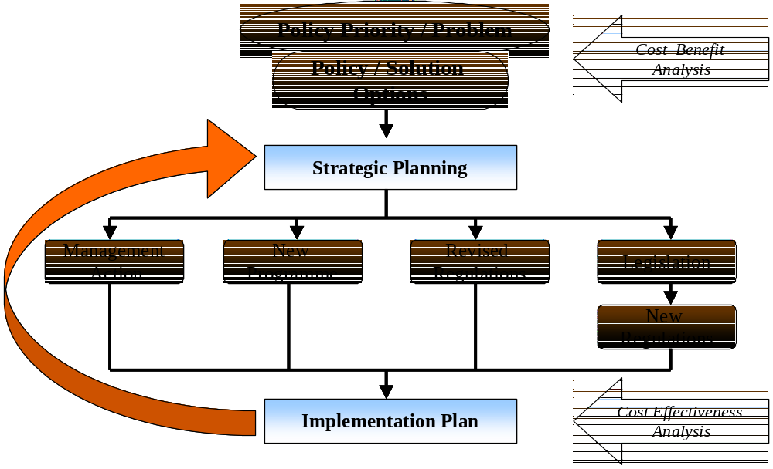

There are some technical and practical considerations which need to be borne in mind when evaluating the results of costing exercises. On the technical side there certain issues that can impact significantly on the outcome of a particular analysis. These include the treatment of the ‘time-value-of-money’ (discount rates), the valuation of different individual’s opportunity costs of time, the value given to a person’s life and the specification and valuation of social and environmental costs and benefits. The CJ-model developed for this project avoids most of these problems given that it focuses exclusively on financial costs incurred in a single year. By the same token, the fact that the model does not capture the social costs and benefits of the different approaches to child justice is a limitation. Similarly, the fact that it presents a static picture of one year rather than a dynamic picture of costs and benefits over a number of years is also a limitation. For instance, with this model it is not possible to reflect the impact that the new system is likely to have on the level of arrests or recidivism over a period of say three to five years.

On the practical side the usefulness of economic analysis is constrained by the quality of the information/data used in the analysis, the skills of the modellers and the time/budget available to finance the research. The latter two issues do not need elaboration. However, the data issue is one which looms large in all areas of economic analysis, particularly in the public sector. It goes without saying that faulty or weak data will impact negatively on the robustness of the analysis. The lack of accurate data also introduces rapidly diminishing returns to greater model complexity. In other words, a simple model based on aggregate data may be as informative and more reliable than a very complex model based on detailed, but poor quality data. It is therefore a generally accepted principle that economic models should be kept as simple as possible. It is also not uncommon for economists to rely on proxy data or assumptions where data on a specific variable is not available. The golden rule is that all such assumptions and use of proxy data should be made explicit so that they can be scrutinised and adjusted in the light of the emergence of better information. The use of proxy data and assumptions is unavoidable when it comes to modelling processes that have yet to be developed, as is the case with the proposed child justice system.

Modelling the Child Justice Bill

Data availability and weaknesses
Data on the flow of children through the child justice system pose many challenges. In most areas they are simply not available. Neither the Department of Safety and Security nor the Department of Justice and Constitutional Development collect data on children in conflict with the law at a national level. The Department of Safety and Security does maintain an extensive database which tracks the reporting of cases, arrests, laying of charges through to convictions for different crime categories broken down by province. However the data do not include any information specific to children. In the re-costing exercise we were not able to use more recent data than that used in the previous costing exercise due to the government moratorium on the release of crime statistics. In other words, all the data relating to total arrests and breakdown of total arrests into different crime categories is based on 1998 data rather than the most recent data. This obviously impacts on the accuracy of the costing, although without knowing to what extent crime patterns have changed since then it is impossible to say what the extent of this impact is. It is nevertheless of great concern that the government should undermine the planning of its own policies by not releasing relevant information.

For the original costing project the Department of Safety and Security did supply information on international crime statistics, which includes details of numbers of children in conflict with the law in other countries (including other developing countries). This information was used to inform assumptions regarding the number of children that are arrested and the division between different types of crime categories (see further discussion in section 2.6).

The Department of Justice supplied extensive information on the functioning of the courts in South Africa in 1997/98. However, we did not use this data directly in the model as we have serious doubts regarding its accuracy. In addition none of the information relates to children specifically.

The Department of Correctional Services supplied useful information regarding the number of children held in prisons and the cost of prison administration. However given that this data only relates to children at the conclusion of the criminal justice process it was only really useful for checking the outcome (in terms of number of children being sentenced to prison) emerging from the CJ-model.

After considering a number of ways of generating proxies for the number of children flowing through the system we decided to use data on children between 7 and 18 years from Census 1996 obtained directly from Statistics South Africa.

Other data relating to the functioning of the system itself or pertaining to costs associated with its functioning are by-and-large reliable. Nevertheless some pieces of information remain uncertain, others were obtained in a format that could not be easily modelled and some were patently out of date. Having said this, it was still necessary to make a large number of assumptions regarding the flow of children from one stage in the system through to the next. These assumptions are, however, made explicit in the model itself and were discussed at great length with Professor Julia Sloth-Nielsen of the Community Law Centre, UWC, as well as other practitioners in different areas of the child justice system.

The CJ-model
The CJ-model is probably best described as a variant of cost-effectiveness analysis, as it enables us to explore and compare the cost-effectiveness of the way children are currently processed by the existing criminal justice system with the system described in the Child Justice Bill. Conventional cost-effectiveness analysis focuses on calculating a cost per unit for two or more methods of service delivery. The CJ-model compares two methodologies for dealing with a given number of children alleged to have committed offences and seeks to establish the most effective methodology in terms of both costs, as well as restorative justice outcomes.

Figure 2 (see below) sets out the structure of the CJ-model. It shows the nine different stages that make up the child justice system and highlights how children in conflict with the law flow through this system, when waiting periods that involve detention exist and at which points children exit the system. The exit options include release (for a variety of reasons) and diversion.

The CJ-model focuses on costing the most significant inputs associated with processing children at each of the nine stages of the criminal justice system. The stages themselves are self-explanatory. In addition to these nine stages, costs are also calculated for diversion, monitoring the child justice system and training.

The inputs that are costed include transport costs, personnel costs, detention costs and costs associated with activities such as age assessment. For more details regarding these costs see Annex 1 which reports all the costing information and other assumptions used in the CJ-model.

Other costs associated with the running of assessment centres, venues for preliminary inquiries, office space, child justice courts, the printing of forms and so forth are not captured by the model. Firstly, certain costs are generic to the broader criminal justice system and will have to be provided irrespective of what shape the child justice system takes, e.g. court facilities. Secondly, certain costs, such as those related to the use of forms, cannot be meaningfully accounted for at high levels of aggregation. In other words including them increases the complexity of the model but adds little to the overall analysis, because they are simply not important cost drivers.

Figure 2: The child justice system as modelled by the CJ-model
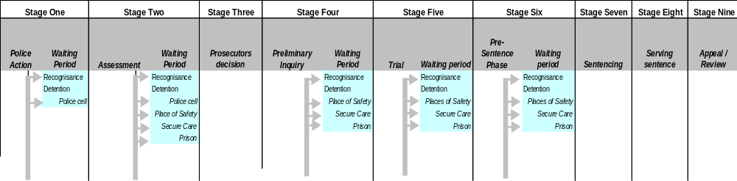
The Child Justice System
Non-residential
Level 1
Level 2
Level 3
Corr. Supervision
Residential
Prison
Reform school
Release
Release
Release
CCI
Diversion
Level 1
Level 2
Level 3
Release
CCI
Diversion
Level 1
Release
CCI
Diversion
Level 1
Level 2
Level 3
Flow of children though the system
Note: CCI = Child Court Inquiry

Variables used in the CJ-model
Broadly speaking the CJ-model relies on two kinds of variables, namely:

1. Process variables that map the flow of children through the criminal justice system. Apart from the initial data on the total number of children between the ages of 7 and 17 years, all process variables are expressed as percentages (e.g. the percentage of children arriving at Stage 2: Assessment that are released on their own recognisance). This approach means that it is possible to change the population to which a scenario applies and still maintain the integrity of the system. Note that even though a large number of process variables determine ‘how’ children flow through the system, the actual number of children at each stage is the key cost driver in the model.

2. Cost variables that are used to cost different activities. These are expressed in terms of:
- Time taken for a particular activity;
- Average cost per hour for the different personnel groups;
- Cost per child processed for particular activities; or
- Distance travelled and cost per kilometre.

Details of all the process and cost variables and assumptions are presented in Annexe 2.

The division into metropolitan, urban and rural areas
A central feature of the CJ-model is the division of the entire criminal justice system into three components, namely metropolitan, urban and rural areas. This division was made for the following reasons:
1. The police crime data shows very clearly that levels of crime are highest in metropolitan magisterial districts, lower in urban districts and lowest in rural districts;
2. The types of reported crimes also differ between metropolitan, urban and rural magisterial districts;
3. Certain costs need to be calculated differently in different areas, most notably transport costs;
4. It is expected that certain practical considerations will mean that it is more cost effective to provide certain services in one area and possibly not in others.

According to the data from Statistics South Africa there are 354 magisterial districts. These were divided up as follows:
- Metro (44 districts),
- Urban (130 districts), and
- Rural (180 districts).

The following table sets out the criteria that we used to allocate magisterial districts to these different categories.
Table 1: Criteria used to allocate magisterial districts to categories
Category | Criteria | Number of districts | %  of total
Metro | Magisterial districts with the largest populations that are more than 70% urbanised | 44 | 12%
Urban | Magisterial districts with populations greater than 50 000 that are more than 50% urbanised.  Magisterial districts with the largest populations that are more than 30% urbanised | 130 | 37%
Rural | All the remaining magisterial districts | 180 | 51%

Annexe 1 presents details of the allocation of magisterial districts to metropolitan, urban and rural categories based on the above criteria. It also shows the provincial breakdown of magisterial districts into the different categories. Detailed demographic information is available on each of these categories, but is not presented with this report.

The following table gives the breakdown of the total number of children between 7 and 18 years of age in each of the above categories. These totals can be used to calculate the level of criminality for this age cohort of the population in different areas and for the country as a whole.
Table 2: Children between 7 and 18 years living in different areas
 | Metropolitan | Urban | Rural | Total for  South Africa
Number of children | 2 995 325 | 2 028 384 | 4 919 388 | 9 943 097
% of total | 30.1% | 20.4% | 49.5 | 100%

Three scenarios for costing the Child Justice Bill
To compare the cost of the current child justice system with that proposed by the Child Justice Bill three scenarios were generated and run in the CJ-model. In these scenarios, the unit costs associated with particular processes or services are assumed to be independent of the number of children in the system and are therefore held constant across the three scenarios. Only the process variables are changed to map the different flows of children in the respective scenarios.

(a) Baseline scenario
This scenario seeks to replicate the flow of children in conflict with the law through the current criminal justice system as closely as possible. It therefore does not include the preliminary inquiry (Stage 4 in Figure 2). In addition significant percentages of children are held in police cells for extended periods of time, are not assessed by probation officers, do not receive legal representation and are remanded to prison while awaiting trial. Similarly very low percentages of children are referred to diversion options in the different stages, with the result that large numbers of children appear in court. Significant numbers are also sentenced to incarceration. In this scenario, an attempt is made to differentiate between the way the criminal justice system functions in metropolitan, urban and rural magisterial districts. This is, however, dependent on the availability of reasonable information to support such differentiation. Where this was not available, or could not be reasonably assumed, the different districts were treated in the same way.

(b) Full (implementation) scenario
The full implementation or ‘full’ scenario seeks to replicate the flow of children through the child justice system as set out in the Child Justice Bill. It therefore incorporates the preliminary inquiry. It is an ideal scenario. Wherever possible the greatest percentage of children are dealt with in the most efficient, child-friendly manner envisaged by the Bill. Therefore the majority of children are taken directly to assessment immediately after arrest, very nearly all children are assessed by probation officers, most children appear before a preliminary inquiry, most children receive legal representation and so forth. The full scenario also provides for the extensive use of diversion options. In this scenario metropolitan, urban and rural magisterial districts are treated uniformly.

(c) Rollout scenario
The rollout scenario seeks to replicate how the new child justice system is likely to function at about the halfway point in the process of implementation. In other words the basic elements of the new system are assumed to be in place, but the assumption is that they are not being uniformly applied or used. This scenario therefore incorporates the preliminary inquiry, a focus on diversion, and other key elements, but assumes that the outcomes differ across the metropolitan, urban and rural magisterial districts. Metropolitan districts are treated in exactly the same way as they are treated in the full implementation scenario, i.e. the system is assumed to operate at maximum effectiveness in terms of the how children are processed and the extent to which diversion and alternative sentencing options are used. In urban districts the new child justice system is assumed only to be achieving about 50 percent of its potential and in rural districts only about 25 percent.

Treatment of serious offences in the scenarios
An important constraint in designing the scenarios is the supposition that the number of children charged and convicted for serious offences should remain more or less constant across each of them. To achieve this, the sentencing outcomes (i.e. number of children receiving sentences in excess of 24 months) generated by the baseline scenario is held constant across the other two scenarios. In other words the actual number of children sentenced to prison for serious offences is assumed to remain the same in each scenario. This translates into an assumption that under the new system the average sentence imposed on children found guilty in court will be far heavier than is currently the case. This may seem counter-intuitive, but it captures an explicit design feature of the new system. The aim of the new system is to divert children accused of less serious offences away from the courts, leaving only the children accused of serious offences to appear in court, hence the longer average sentences.

Number of children entering the criminal justice system
The number of children entering the criminal justice system is probably the most important variable for the CJ-model. As noted above, the Department of Safety and Security does not collect national data on children coming into conflict with the law. It was therefore necessary to develop a proxy variable for the number of children entering the criminal justice system each year. Table 3 sets out the data and assumptions that were used in this calculation, and also shows the calculation itself. Note that this information remains unchanged for each of the scenarios. This is the despite the change in the age of criminal capacity introduced by the Child Justice Bill (see section 2.6.1).
Table 3: Number of children entering the criminal justice system per year
Calculation Process | Metro | Urban | Rural | Total for South Africa
Total Child Population | 2 995 325 | 2 028 384 | 4 919 388 | 9 943 097
Total number of cases reported |  |  |  | 2 224 000
% of total number of cases attributed to children¹ |  |  |  | 15%
Number of cases attributed to children |  |  |  | 333 600
% distribution of cases across magisterial districts² | 60% | 35% | 5% | 100%
No. of cases in magisterial district categories | 200 160 | 116 760 | 16 680
% cases untraced or unfounded³ |  |  |  | 60%
Number of cases untraced or unfounded | 120 096 | 7 0056 | 10 008
Number of cases allegedly involving children proceeding beyond police action | 80 064 | 46 704 | 6 672 | 133 440
% of cases involving immediate arrest by the police⁴ |  |  |  | 75%
Number of cases involving immediate arrest by police | 60 048 | 35 028 | 50 04 | 100 080
% of cases only involving dockets initially |  |  |  | 25%
Number of cases only involving dockets initially⁵ | 20 016 | 11 676 | 1 668 | 33 360
Notes to table
1. It is estimated that 15% of the total number of cases reported in South Africa for the period January to December 1998, namely 2224000 cases, are attributable to children (Department of Safety and Security, pers. com.). This is comparable to the percentage of cases attributed to children in other countries: England and Wales (25%), New Zealand (23%), Canada (22%), Netherlands (20%), USA (19%), France ((18%), Swaziland (16%), Poland (15%), Austria (14%), Germany (13%), Korea (12%), Chile (6%). (Interpol, 1996)
2. This breakdown is based on discussions with Superintendent Niels Nilsson of the SAPS Provincial Child and Youth Desk, Western Cape. According to him over 70% of arrests involving children in the Western Cape take place in the Cape Town metropolitan area (pers. com.)
3. According to data from the Department of Safety and Security 56% of all cases reported to the police in 1998 were either untraced (54%) or unfounded (2%). Given that children are more likely to be involved in offences that go untraced (such breaking into cars) 60% probably slightly underestimates the number of cases involving children that go untraced.
4. This assumption is based on discussions with Superintendent Niels Nilsson, Professor Sloth-Nielson of the Community Law Centre at UWC and Lukas Muntingh, Director of Research and Information at NICRO.
5. These ‘docket cases’ do not involve immediate arrest. The police open a docket and forward it to the Director of Public Prosecutions for a decision as to whether to proceed with it. In most instance an alternative to arrest (e.g. summons) is used should a decision be taken to take the case further.

Age and criminal capacity
Section 6(1) of the Child Justice Bill specifies, “A child who, at the time of the alleged commission of an offence, is below the age of ten years cannot be prosecuted”. This issue was still being debated when the original costing was done and so the common law minimum age of prosecution was used. We have decided to stay with the common law position in the different scenarios, because there is no information on how many children will be excluded from prosecution as a result of this provision. Nevertheless we expect the numbers to be very small and therefore this provision will have minimal impact on the overall cost of the proposed child justice system, although it is very important from a justice perspective.

Breakdown of cases by crime category
Having determined the total number of likely cases involving children entering the criminal justice system each year, it is also necessary for costing purposes to break the cases down according to crime category. Table 4 gives details of the information on which the assumptions used in the CJ-model are based, as well as the assumptions themselves.
Table 4: Initial breakdown of cases by crime category
Crime Category | Offences included in  crime categories | Cases in each category as % of total cases reported in 1998 | % breakdown of cases used in  CJ-model
Crime Category | Offences included in  crime categories | Cases in each category as % of total cases reported in 1998 | Cases arising from immediate police arrest | Docket cases
Economic | Burglary (business), burglary (residential), stock theft, shoplifting, vehicle theft, theft out of car, other theft, arson, malicious damage to property, all fraud. | 62.38% | 65% | 60%
Aggressive | Murder, attempted murder, culpable homicide, robbery with aggravating circumstances, other robbery, public violence, crimen injuria, kidnapping, assault with intent to harm, common assault. | 31.56% | 29% | 40%
Sex | Rape (and attempts), indecent assault | 2.46% | 3% | 0%
Narcotics | All drug related crimes | 1.79% | 1.5% | 0%
Other | Illegal firearms, drunk driving | 1.80% | 1.5% | 0%

Note that in each of the scenarios the same initial breakdown of cases by crime category is used. Also no differentiation is made between metropolitan, urban and rural magisterial districts. This is probably an oversimplification. It is generally accepted that patterns of criminality differ significantly between urban and rural areas, but in the absence of any information on these differences the national aggregate breakdown reflected above was used.

Discussion of results: comparing the three scenarios

Overall process outcomes
The following figures summarise the overall process outcomes of the three scenarios.

The flow of cases through the child justice system
Figure 3 shows very clearly that the rollout and full scenarios are more effective than the baseline scenario in ensuring children exit the child justice system as early as possible. It also shows that in all three scenarios the greatest number of cases reported, and by implication, the majority of children in conflict with the law, are dealt with in one way or another prior to being taken to court. In most instances the charges are simply dropped.
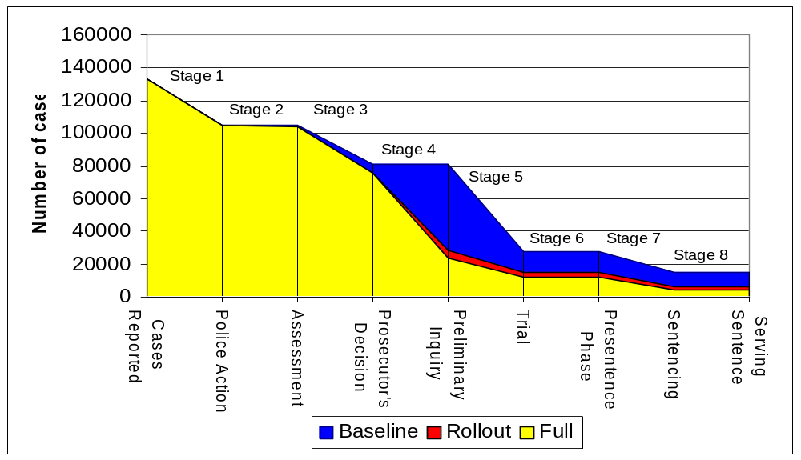
Figure 3: Annual number of cases remaining in the child justice system at the end of each stage

Also noticeable is the very large number of children (80 800) who are taken to court in the baseline scenario. However, little more than one third (27 800) of them are actually sentenced. Under the full scenario only about 23 250 children appear in the child justice court each year of whom about 6 000 are diverted during the court process, 1 150 referred to alternative dispute resolution and 11 880 are actually convicted. In other words more than 80 percent of cases appearing in the child justice court result in either a conviction or some other positive action being taken such as diversion or referral to alternative dispute resolution.

The use of diversion and alternative sentencing options
Figure 4 shows that both the full and rollout scenarios rely heavily on all the different forms of diversion as a means of getting children out of the criminal justice system either prior to or during the court process. This figure also shows that in the full and rollout scenarios, diversion programmes are also used as an alternative to sentencing children to prison. The high number of children being diverted is in accordance with the Child Justice Bill’s focus on restorative justice. This figure also indicates that the new child justice system is likely to be far more effective in actually dealing with children who commit offences. In the full scenario nearly 68 000 children are either referred to some form of diversion, dispute resolution or receive an alternative or residential sentence. This represents more than half the total number of children that allegedly commit offences and enter the criminal justice system. By contrast, in the baseline scenario only 26 100 children are diverted or sentenced. This is only about 20 percent of those who enter the criminal justice system.
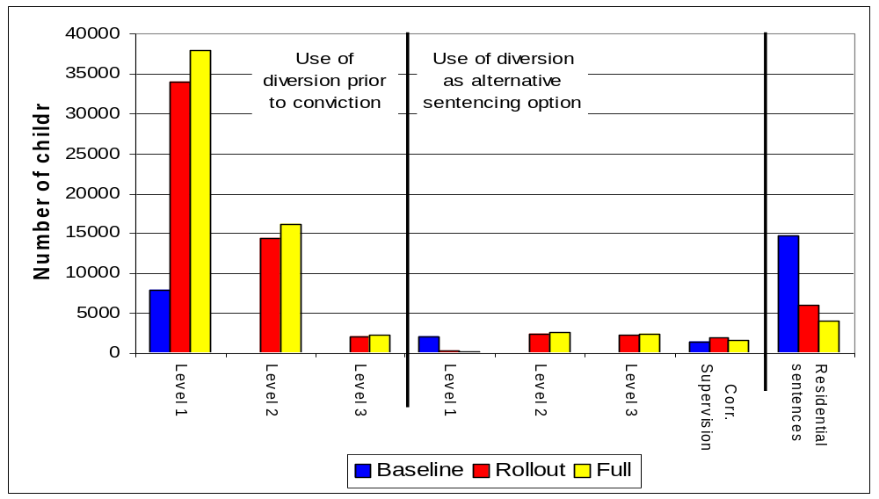
Figure 4: Total number of children diverted each year

In the baseline scenario children are only diverted to a limited subset of level 1 diversion options, as these are the only options currently available in a formal sense. There is nevertheless general acceptance that police, prosecutors and magistrates make use of cautions and other forms of ‘diversion’. Some of these need to be encouraged, others are not in the best interest of children and should be discouraged.

Children given residential sentences (reform school and prison)
Figure 5 also shows that the new child justice system will significantly reduce the number of children receiving residential sentences. In the baseline scenario, over 14 700 children are given residential sentences: almost 14 200 are sentenced to prison and 550 to reform schools. The full scenario suggests that the number of children sentenced to prison can be reduced by two-thirds, down to some 3 420 children per year. The number of children sentenced to reform school would increase very slightly to about 590 per year. About 80 percent of the prison sentences in the full scenario would be for sentences of longer than two years, whereas in the baseline scenario 80 percent of sentences are for periods of less than two years.
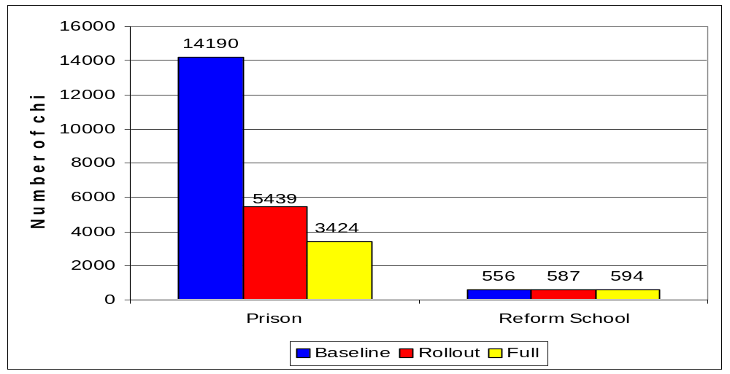
Figure 5: Total number of children given residential sentences each year

Children held in detention
Figure 6 shows that under the baseline scenario, children are held in detention in police cells or in prison for a total of 1 288 000 days per year (611 000 days in police cells and 677 000 days in prison). In other words, it is estimated that children currently spend over 3 530 person-years in police cells or in prison each year without sentence. Moreover, more than 20 percent of the time children spend in police cells is prior to their first appearance in court. It is difficult to calculate exactly how many children this affects as the same child might be admitted to a police cell and then to prison a number of times during the course of his/her progress through the criminal justice system. However it is possible to get some idea by making a number of rough assumptions:
- Assuming the average detention period in a police cell is one week, then over 87 000 children are held in police cells during the course of a year. This is only slightly less than the total number of children we calculated are arrested each year. Obviously many children will spend shorter periods in police custody, but by the same token many will be held for much longer.
- Assuming that the average period of detention in prison is 6 weeks, then some 16 000 children are held in prison during the course of a year. This is corroborated by data from the Department of Correctional Services which shows that some 15 900 unsentenced children were admitted to prisons during 1998.
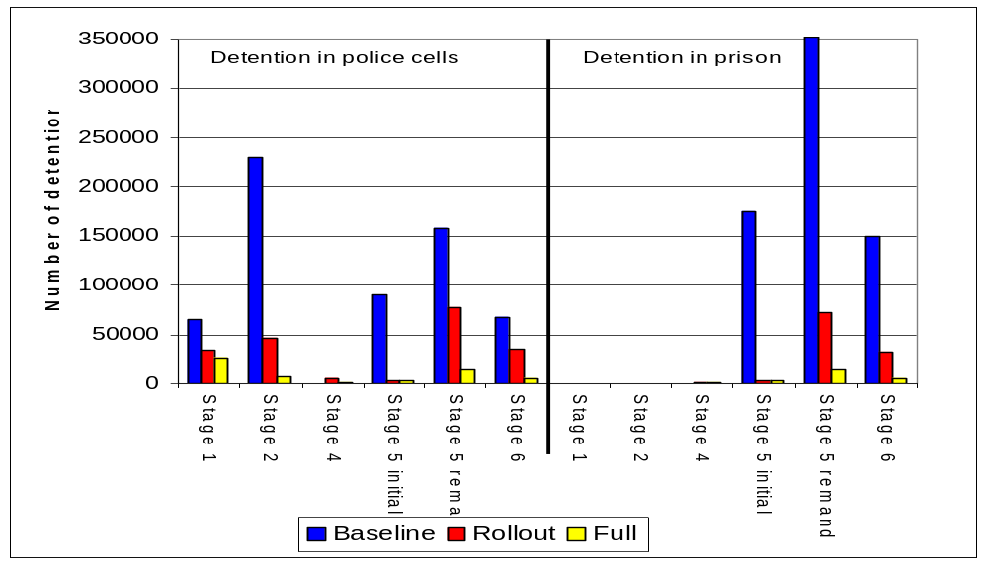
Figure 6: Total number of days children are held in detention each year

Figure 6 also shows that of the 677 000 days that children are held in prison over three-quarters of these days are spent by children in the process of being tried. In other words it is estimated that children spend about 1445 person-years in prison prior to the court making any ruling on their innocence or guilt and a further 410 person-years prior to sentencing. The social and economic implications of these extended detention periods are enormous.

Far more important is that Figure 6 shows that the child justice system proposed by the Child Justice Bill would greatly reduce the holding of children in police cells and almost eliminate the use of prisons for detaining children. In the full scenario it is estimated that children will be detained for some 58 000 days in police cells and some 25 000 days in prisons. This is a reduction of some 96 percent over the baseline scenario. This is achieved by:
- getting children out of the criminal justice system as early as possible through the use of police cautions and diversion at assessment and at the preliminary inquiry, or even during the course of a trial;
- substantially reducing the time period associated with trials of children in the child justice court (this is possible due to the smaller number of cases being brought to trial); and
- referring children to places of safety or holding them in secure care facilities.

The following figure shows the number of days children are held in places of safety and secure care each year. It is generally thought that to reduce the number of children detained in police cells and in prison many more places of safety and secure care facilities will need to be built. It is clear from Figure 7 that the number of new facilities is likely to be far less than might have been expected.
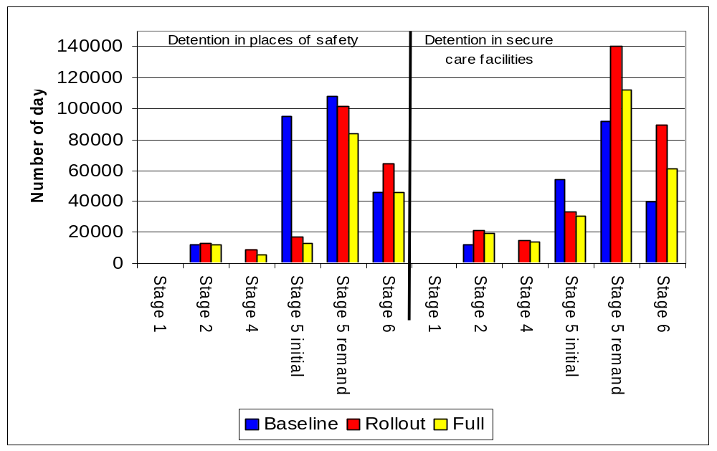
Figure 7: Total number of days children held in places of safety and secure care each year

Figure 7 shows that the total number of days children are held in places of safety and secure care facilities declines between the baseline and full scenarios. This may seem somewhat surprising given the greater use of these detention options in percentage terms in the rollout and full scenarios. For example in Stage 5: Trial of the baseline scenario, only 5 and 20 percent of children alleged to have committed aggressive offences are detained in places of safety or secure care facilities respectively. By contrast, in the full scenario the comparative percentages are assumed to be 10 and 40 percent. And yet Figure 7 shows that the number of days that children are held in places of safety declines from 261 000 to 160 000 between the baseline and full scenarios. In other words, the implementation of the new child justice system is expected to cause the demand for places of safety to drop by some 40%. As in the case of the drop in detention in police cells and prisons this can be ascribed to the factors mentioned above, most notably the drop in the number of children being tried in court and the reduction in the average length of trials.

By contrast the number of days children are held in secure care is expected to increase from 196 000 to 237 000 between the baseline and full scenarios. The overall number of days children will spend in secure care facilities and prison in the full scenario is still significantly less than the number days children currently spend in secure care facilities and prison in the baseline scenario: 262 000 versus 873 000 days. This is more than a two-thirds reduction in detention days. Detention in secure facilities therefore replaces detention in prison only to a very limited extent in the full scenario.

Figure 7 also shows that the number of children held in secure care facilities is likely to first increase in the rollout scenario before declining in the full scenario. This is due to two factors:
- while the new child justice system is being implemented larger numbers of children will go through the preliminary inquiry and end up in court and therefore have to be detained in secure care facilities, and
- the trial process will be longer during the implementation process due to the larger number of children the child justice courts will have to deal with, hence the time a child is detained in a secure care facility will be longer in the rollout scenario than in the full scenario.

Given the limited number of secure care facilities it is going to be a significant challenge to ensure sufficient are built to meet the long-term demand. In our view more work is required on this aspect of the costing exercise to ensure that we are working with accurate numbers.

Nevertheless it is clear that should the new child justice system not be implemented, but a separate policy decision is taken not to detain children in prison, the demand for secure care facilities would be very much greater, probably more than three times the number that we project under the full scenario.

It must be emphasised that the demand for accommodation in places of safety and secure care facilities is directly linked to the operational efficiency of the child justice system. The fewer the delays in processing children at each stage of the system, the lower the demand for detention facilities will be.

Overall cost outcomes
The following figures summarise the overall cost outcomes of the three scenarios.

Total annual cost of the child justice system
Using the baseline scenario, it is estimated (using input costs for 2000) that the government currently spends about R787 million per year on dealing with children in conflict with the law. Figure 8 shows that the full scenario suggests that the implementation of the child justice system proposed by the Child Justice Bill could reduce this to about R606 million per year. This implies a saving of about R180 million per year on current levels of expenditure or an annual saving of over 20 percent. The rollout scenario indicates that substantial savings would still be realised even if the new child justice system were only fully implemented in metropolitan areas, and to a lesser extent in urban and rural areas.

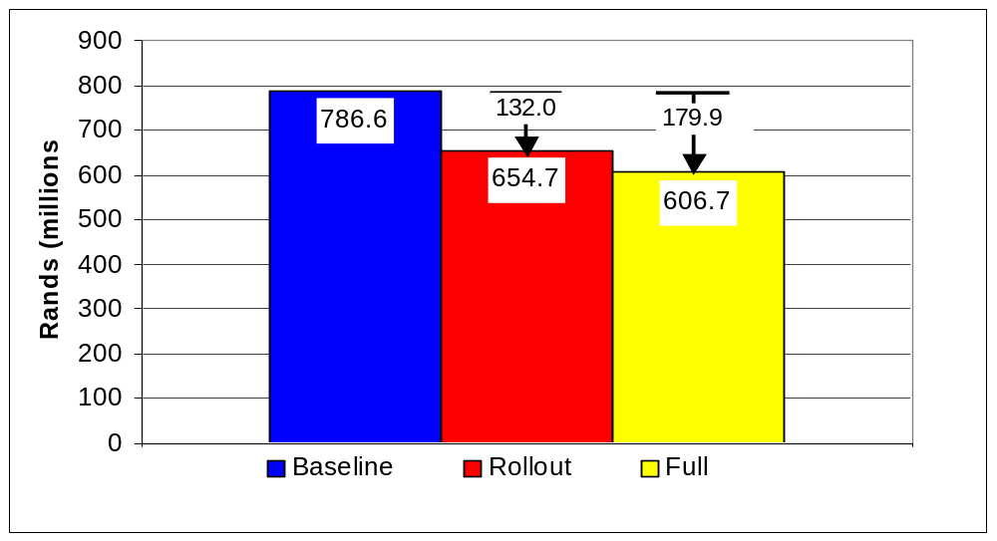
Figure 8: Total annual cost of each scenario of the child justice system

Note that while the overall totals presented above are sensitive to changes in the actual levels of the cost variables (e.g. the hourly rate of probation officers or the cost of different detention options), the percentage gap between the baseline and full scenarios is fairly robust. This means that even if certain of the cost variables are changed this will not impact significantly on the percent of savings expected to be realised by shifting from the baseline to the full scenario.

Note that the level of total expenditure in each scenario is most sensitive to the per day cost of keeping a child in prison (currently set at R80.80 per day according to the Department of Correctional Services, followed by the cost of transport (currently set at R3.00 per kilometre) and the unit cost of diversion options. The information used to estimate the unit cost of these particular variables is, however, considered to be very reliable. The level of total expenditure in each scenario is less sensitive to changes in the unit cost of personnel because in most instances such costs are simply being reallocated between different stages of the child justice system.

It must also be emphasised that the CJ-model does not cover all the personnel and administrative costs associated with the court system. If these costs were to be included the level of savings would in all likelihood be far higher, given that the number of cases referred to court falls dramatically between the baseline and full scenarios.

Breakdown of costs according to stage
Table 5 gives a breakdown of the above cost totals for each of the scenarios according to the different stages of the child justice system as described in Figure 2. It also includes the costs of diversion, monitoring and training. The right hand column shows actual decreases (-) or increases (+) in expenditures between costs in the baseline scenario and costs in the full scenario
Table 5: Breakdown of annual costs by stage for each scenario
(Rands millions) | Baseline | Rollout | Full | Change between Baseline & Full
Stage 1 | 45.8 | 57.3 | 58.4 | 12.7
Stage 2 | 26.9 | 34.5 | 43.4 | 16.5
Stage 3 | 3.6 | 3.6 | 3.6 | 0.0
Stage 4 | 0.0 | 57.1 | 58.7 | 58.7
Stage 5 initial | 93.6 | 34.8 | 34.2 | -59.4
Stage 5 remanded | 91.8 | 47.7 | 31.7 | -60.1
Stage 6 | 27.3 | 25.5 | 15.7 | -11.6
Stage 7 | 14.1 | 8.5 | 6.5 | -7.6
Stage 8 | 473.1 | 349.0 | 316.4 | -156.8
Stage 9 | 3.0 | 1.5 | 1.1 | -1.9
Diversion | 6.5 | 28.6 | 30.4 | 23.9
Training | 0.0 | 1.8 | 1.8 | 1.8
Monitoring | 0.8 | 4.8 | 4.8 | 4.0
Total | 786.6 | 654.7 | 606.7 | -179.9

Table 5 shows that the child justice system proposed by the Child Justice Bill will not only reduce expenditures, but will also result in a significant reallocation of where money is spent. Indeed, looking at the process outcomes above, it is clear that the new child justice system will save money, as well as ensure the more effective use of the remaining expenditure.

The expenditure on residential sentences versus expenditure on diversion is a case in point. Table 5 shows that expenditure on serving residential sentences (Stage 8) falls by R157 million or 32 percent between the baseline and full scenarios, while expenditure on diversion increases by some R24 million. So between these two processes there is a net saving of some R133 million. Furthermore, in the region of 10 000 fewer children are sentenced to prison while approximately 50 000 more children are dealt with using one or other diversion option or alternative sentencing option. In other words money is being saved and outcomes (e.g. cases being dropped and prison sentences) that have minimal restorative justice value are replaced by outcomes that are positive both for the children concerned and for society more widely.

Table 5 shows that very significant savings could be realised in the court trial stages (namely Stages 5, 6, and 7). It is estimated that the new child justice could save a substantial R139 million in these stages alone. Much of this can be attributed to reduced detention costs (see section 3.5.1). However in order to realise these savings greater expenditure is needed at the front end of the child justice system, most notably in Stages 2 and 4. The estimated increase of R75 million across Stages 2 and 4 is necessary to leverage the potential savings in the later stages.

It cannot be emphasised enough that these initial stages and the provision of diversion must be adequately financed; as it is here that the overall success of the proposed changes to the child justice system will be determined. If children are not properly assessed, if the preliminary inquiry is not effective in diverting cases, and if diversion is not properly funded and organised then the enormous inefficiencies which currently exist in the court system will persist.

Allocation of costs to different expenditure items
Considering the different items of expenditure in relation to the overall cost of the child justice system Figure 9 confirms the dominance of expenditures associated with children serving prison sentences. In the baseline scenario about 55 percent of the overall expenditure on the child justice system goes towards paying for children serving prison sentences. A further 18 percent of expenditure in the baseline scenario goes to paying for detention. This means that nearly 75 percent of total expenditure on the current child justice system finances detention and prison sentences. The full scenario suggests that this can be reduced to about 55 percent, with detention costs being reduced to 9.5 percent of overall expenditure.
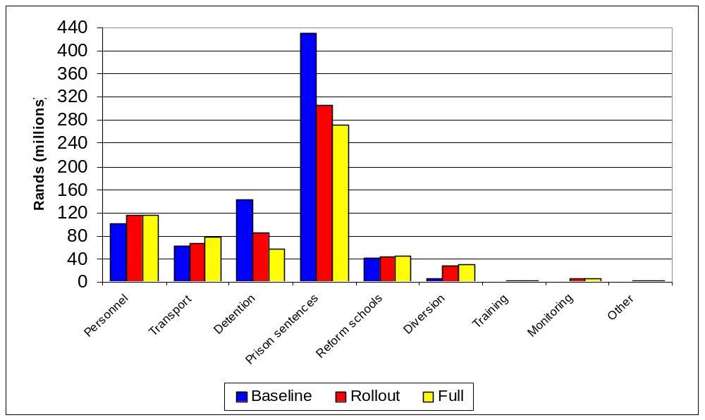
Figure 9: Allocation of annual costs to different expenditure items in each scenario

Expenditure on personnel in the departments of Safety and Security, Justice and Social Development (Welfare) represent about 13 percent of overall expenditure in the baseline scenario. This increases to about 19 percent of overall expenditure in the full scenario. Actual expenditure on personnel is expected to increase by about R14 million.

Somewhat surprisingly the cost of transporting children caught up in the child justice system is an important expense. It is estimated that in the baseline scenario about 8 percent of total costs go towards this item. This does not reflect the full cost of providing such transport, because the associated personnel costs to the Department of Safety and Security are included under personnel. In the rollout and full scenarios transport’s share of overall expenditure increases to 10 and 13 percent respectively, while actual expenditure increase by R16 million or by some 25 percent. The reason for this increase is that it is expected that to make the new child justice system work the police are going to have to transport children between different venues more regularly in the early stages. This is offset to some extent by savings in the later stages.

Figure 9 also emphasises that the cost of setting up a system for monitoring the child justice system and the cost of providing training are relatively minor expenditures compared with the overall cost of the child justice system. However, these expenditures are key to the success of the new justice system. Trying to effect marginal savings in these areas could greatly impact on their effectiveness, and reduce the overall effectiveness of the implementation and ongoing operation of the new child justice system. Thus trying to effect marginal savings in these areas could incur great costs in the rest of the system.

It is evident from Figure 9 that most of the savings associated with implementing the new child justice system can be attributed to reduced expenditure on prison sentences and on detention. The savings on these items between the baseline and full scenarios amount to R160 million for prison sentences and R84 million for detention. This is a 37 percent reduction in the case of prison sentences and a 60 percent reduction in the case of detention. We regard these estimates to be robust.

As noted expenditure on personnel and transport increases by R16 million (25 percent) and R14 million (13 percent) respectively between the baseline and full scenarios. These estimates are less robust; nevertheless, that increased expenditure on these items will be required is fairly certain.

Impact of wider use of One-Stop Child Justice Centres
The latest version of the Child Justice Bill provides for the establishment of One-Stop-Child Justice Centres (see section 72). This is a welcome addition to the Bill as it is clear that such centres will be required to implement its provisions effectively, especially in metropolitan areas. The Inter-Ministerial Committee on Young People at Risk has conducted a number of pilots to test the efficacy of such centres. Reports proving their general efficacy and economy are available.

The following two sections focus on the opportunities the assessment components of such One-Stop Child Justice Centres offer to reduce the widespread use of detention in police cells. For a suggested distribution of One-Stop Child Justice Centres across the country see Annex 4.

Cost of police detention vs rapid assessment
Figure 10 shows the cost of detaining children in police cells in Stages 1 and 2 versus the cost of assessment in Stage 2 (see Figure 2). The variables underlying these results assume that in the full scenario:
- Children will spend a minimum of time in police custody. Indeed, it is assumed that in metropolitan, urban and rural areas respectively 75, 50 and 25 percent of children arrested will be taken directly to assessment, compared with an average of just 7 percent in the baseline scenario. This effectively reduces the amount of time children need to spend in police custody.
- Very nearly all children coming into conflict with the law will be assessed. In the baseline scenario it is estimated that only about 47 percent of children are currently assessed.

On the basis of the above assumptions, Figure 10 shows that the cost of police detention in the initial stages of the child justice system can be reduced from R14 million in the baseline scenario to about R1.6 million in the full scenario. This very nearly offsets about half the increase in assessment costs from R13 million in the baseline scenario to R39 million in the full scenario. Much of this increase in costs in Stage 2 is as a result of increased transport costs and the associated personnel costs of police officers. This is where One-Stop Child Justice Centres come into their own: by reducing the need to transport children from one venue to another and by facilitating the rapid processing of children through a number of stages in the child justice system within a short period of time, these centres reduce the need for such transport. Obviously the savings in transport costs are important, but by no means the most significant benefits of these One-Stop Child Justice Centres. The more important benefits relate to justice outcomes.
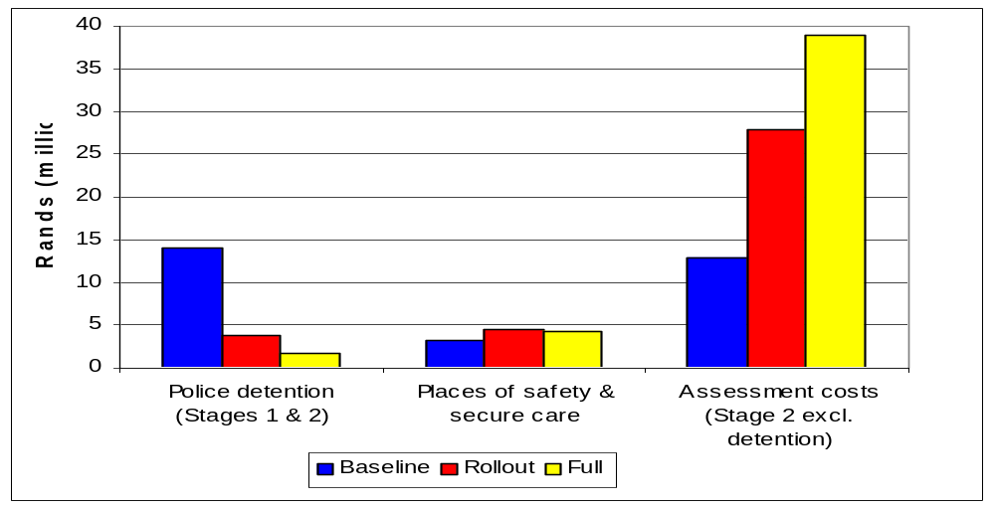
Figure 10: Annual cost of police detention after arrest versus annual cost of rapid assessment

The more effective use of alternative residential/detention facilities
Figure 11 shows the total number of days that children are detained in police cells, places of safety and secure care in Stages 1 and 2 of the child justice system. The dramatic decrease in the number of days children are held in police cells between the baseline and full scenarios is a direct result of the police taking most of the children they arrest directly to assessment in the latter scenario.
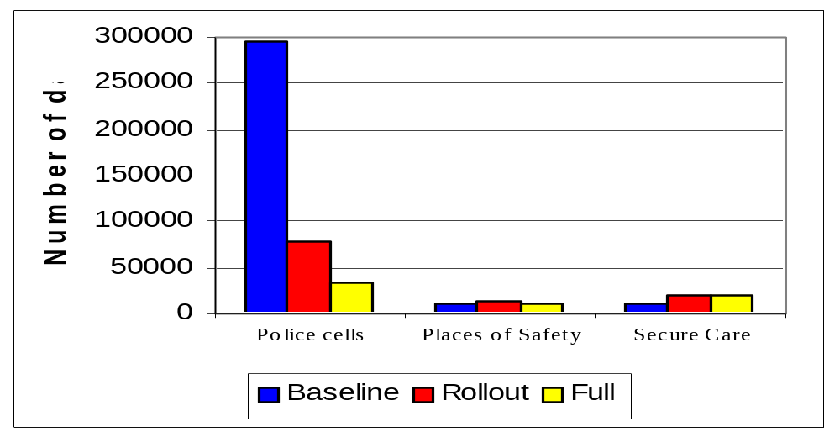
Figure 11: Number of days children spend in residential/detention facilities in Stages 1 and 2

The fact that the number of days children spend in places of safety and secure does not change much between the scenarios does not imply that the actual number children referred to these facilities in the different scenarios does not change. Indeed, Table 6 shows that in the full scenario 6 100 and 9 700 children are referred to places of safety and secure care respectively, compared with 3 000 and 2 900 children respectively in the baseline scenario. However, because the time children spend in these facilities is very much less in the full scenario there is little change in the demand for places in these facilities.
Table 6: Annual number of children admitted to detention/holding facilities in Stages 1 and 2
Residential/detention facility | Baseline Scenario | Rollout Scenario | Full  Scenario
Police cells | 122 494 | 48 509 | 30 011
Places of Safety | 3 050 | 4 379 | 6 136
Secure Care | 2 935 | 6 916 | 9 691

Impact of introducing the preliminary inquiry
Probably the most innovative section of the Child Justice Bill is Chapter 7, which introduces the preliminary inquiry as a key component of the new child justice system. A preliminary inquiry must be held in respect of every child in the child justice system. The stated objectives of the preliminary are set out in section 56(4) of the Bill and include to:
- Ascertain whether a probation officer has assessed the child;
- Establish whether the matter can be diverted before plea;
- Identify a suitable diversion option where applicable;
- Establish whether the matter should be referred to a child court inquiry;
- Provide opportunity for the prosecutor to assess whether there are sufficient grounds for the matter to proceed to trial;
- Ensure all relevant information is available to inform decisions on diversion and placement of the child;
- Ensure all views of persons present are considered before a decision is taken;
- Encourage the participation of the child and his or her parent or an appropriate adult in decisions; and determine the release or placement of the child pending conclusion of the preliminary enquiry, appearance of the child in court or transfer of the matter to a children’s court.

It is envisaged that by getting the inquiry magistrate to follow the process set out in sections 59 to 67 of the Child Justice Bill at the preliminary inquiry a large number of cases that currently enter the court system will either be diverted or dropped before plea in court. The preliminary inquiry can best be described as a method of screening cases in order to determine:
  - which cases should be dropped,
  - which cases should be diverted and
  - which cases should be tried in the child justice court.

Given the informal character of the preliminary inquiry it is expected to be a fairly speedy and cost effective method of processing matters. It was assumed that the average preliminary enquiry would last just 45 minutes. The cost effectiveness of this procedure is highlighted below.

Savings in total court costs due to use of preliminary inquiry
Figure 12 shows that significant savings can be made in the trial process by introducing the preliminary inquiry. As expected the major savings are associated with reduced detention costs and transport costs as a result of fewer cases being brought to trial and the cases being dealt with more quickly.

The changes in personnel expenditure are also significant, especially in the light of the fact that there is a direct trade-off between the time magistrates and prosecutors spend at the preliminary inquiry and the time they spend trying cases in court. The relevant figures are set out in Table 7
Table 7: Magistrates and prosecutors hours in the different scenarios
Stage  (no. of hours) | Baseline | Rollout | Full | Change between Baseline & Full
Prosecutors
Stage 3 | 52 513 | 52 088 | 52 022 | -491
Stage 4 | 0 | 95 176 | 94 618 | 94 618
Stage 5 | 212 970 | 103 193 | 88 801 | -124 169
Stage 7 | 40 302 | 25 345 | 21 369 | -18 933
Total | 305 784 | 275 802 | 256 810 | -48 974
Magistrates
Stage 3 | 0 | 0 | 0 | 0
Stage 4 | 0 | 95 176 | 94 618 | 94 618
Stage 5 | 212 970 | 103 158 | 88 772 | -124 198
Stage 7 | 40 302 | 25 345 | 21 369 | -18 933
Total | 253 272 | 223 679 | 204 760 | -48 512

It is estimated that magistrates currently spend a total 253 000 hours trying cases involving children. In the full scenario it is expected that the total amount of time magistrates will spend actually trying children in the child justice court will be about 110 000. In other words magistrates’ time in court dealing with children is set to decline by some 140 000 hours or 57 percent. This sharp decline in court time for magistrates is offset to some extent by the new time demands of the preliminary inquiry. However, overall the new child justice system is expected to enable magistrates to save about 49 000 hours or about 19 percent. This is a significant improvement in efficiency and will contribute to the better functioning of courts as a whole.

The time savings for prosecutors are of the same order of magnitude. It is estimated that currently prosecutors spend some 306 000 hours dealing with children in conflict with the law. With the implementation of the Child Justice Bill this is expected to fall to 257 000 which represents a saving of 16 percent. Again most of the time saving occurs due to less time spent in court, which is leveraged by time spent at the preliminary enquiry. It should be noted that in order to realise these time savings it is absolutely essential that both magistrates and prosecutors allocate sufficient time to preliminary enquiries

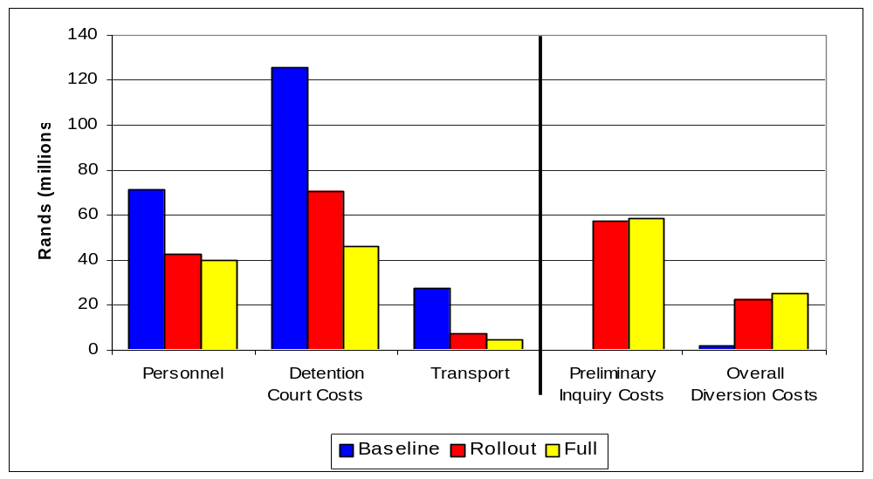
Figure 12: Annual cost of preliminary inquiry (Stage 4) and total court costs (Stages 5, 6 and 7)

Figure 12 also highlights the fact that the savings in detention costs during the trial process more than offset the increased expenditure on diversion. Not only that, few would disagree that the money spent on diversion is used more constructively than it would be if it were spent on detaining children in prison for minor offences.

Overall savings made on court cases more than offset the additional expenditure required to run the preliminary inquiries

Impact on number of cases involving children brought before the court
One of the central aims of the new child justice system is to reduce the number of cases involving children that are brought before the courts. As noted, the preliminary inquiry, together with diversion, is the key mechanism for achieving this. Table 8 shows the number of cases that are processed at the different stages of the child justice system in each of the scenarios.
Table 8: Annual number of cases arriving at different stages in the child justice system
 | Baseline Scenario | Rollout Scenario | Full  Scenario
Stage 3: Prosecutors Decision Total | 105 026 | 104 176 | 104 044
Stage 4: Preliminary Inquiry Total | 0 | 71 701 | 71 024
Stage 5: Trial Total | 80 807 | 28 706 | 23 269

It is evident that the preliminary inquiry impacts not only on the number of cases being brought to court, but also on the number of cases that prosecutors decide to bring even to the preliminary inquiry itself. In the baseline scenario it is estimated that prosecutors drop or divert about 25 percent of the cases they process, whereas in the full scenario it is estimated that they drop about 30 percent of the cases they process. Most of the cases dropped are likely to be so-called ‘docket cases’ identified in Table 3, which are currently mostly dropped or withdrawn anyway. Prosecutors are likely to drop these cases because in order to proceed with them they need to secure the presence of the child implicated in the case at a preliminary inquiry. The effort this is likely to require will in most instances be disproportionate to the nature of the alleged offence.

It is estimated that of the 71 000 cases that are brought before a preliminary inquiry in the full scenario, about two-thirds of them will be diverted, transferred to a children’s court inquiry or dropped due to lack of evidence. This means that in the new child justice system only about 23 200 cases involving children are expected to be referred to court each year. Compared to the baseline scenario, this is just over a quarter of the cases that are currently being referred to court.

Impact on backlogs in the court system
The CJ-model does not deal with court backlogs directly. Nevertheless, the fact that implementing the new child justice system will mean that fewer cases involving children are referred to court could help to reduce current backlogs. In addition, the fact that in the full scenario the child justice system as a whole will require some 19 percent less magistrates’ time means that this becomes available for use elsewhere in the justice system. Similarly prosecutors will spend 16 percent less time on the child justice system in the full scenario than in the baseline scenario which means they will be able to reallocate this time to other areas of justice as well. For a more detailed analysis of these savings see discussion in section 3.4.1.

Children held in detention
Figure 6 and Figure 7 above show the enormous reduction in the number of days children are held in detention each year as a result of the overall implementation of the new child justice system. Much of the reduction during the trial stages can be attributed directly to the use of the preliminary inquiry as a screening and diversion mechanism.

Impact of wider use of diversion/alternative sentencing options
Central to the success of the new child justice system is the wider of use of diversion and alternative sentencing options as proposed in the Child Justice Bill in Chapter 6 and elsewhere. This is in line with the overall principles set out in section 5 of the Bill.

Diversion and alternative sentencing give content to the overall restorative justice aims and focus of the Bill. These instruments encourage children in conflict with the law to be accountable for the harm their actions have caused and seek to reintegrate them into their families and communities. A further purpose of diversion is to prevent the stigmatisation of a child through contact with the criminal justice system. The Bill could have gone further and noted that by keeping children out of prison, diversion and alternative sentences are likely to play an important role in breaking the cycle of criminality in South Africa, given that prisons are one of the main recruiting arenas for gangs.

The medium term benefits to society of early and effective diversion, as well as alternative sentences, are likely to include the restoration of respect for the law, reduced levels of criminality and safer living environments. This study did not attempt to quantify these benefits, but there can be little doubt that they are exceptionally significant. From the perspective of the criminal justice system, diversion and alternative sentencing enable very significant cost savings to be realised due to reduced use of residential sentences. Diversion and alternative sentencing also represent a more effective use of funds insofar as they deal with children in conflict with the law at an early stage, before they get caught in a cycle of criminality.

Cost of diversion versus cost of residential sentences
Table 9 shows the unit cost of different diversion and sentencing options. It is clear that residential sentences are vastly more costly than diversion and non-residential sentences. Couple this to the fact that diversion and non-residential sentences are generally more effective from a restorative justice point of view, and it becomes obvious that these options should be used instead of residential sentences wherever possible.

The Department of Correctional Services itself highlights in its Annual Report 1999/2000 the fact that community-based sentences are vastly more cost-effective than residential-based sentences. This costing merely reconfirms this point.

Table 9: Unit cost of different diversion and sentencing options
Diversion/Sentencing Options  (Rands) | Per Day Cost Per Child | Total Cost  Per Child
Diversion/Non-Residential Sentence Options¹
Level 1 Options
Formal Caution |  | 11
Reporting Orders (e.g. school attendance etc.) |  | 54
Yes programme |  | 183
Level 2 Options
Family Group Conference |  | 215
50hrs Community Service |  | 175
12 week/5hrs per week programme |  | 861
Level 3 Options
6 month/20hr per week programme |  | 1076
3 month/35 nights periodic residential programme |  | 1937
250hrs Community Service |  | 269
6 month/35hr per week programme |  | 1291
Correctional Supervision (1year)² | 9.5 | 3 467
Residential Sentence Options
Reform School (1 year)³ | 188.3 | 37 660
Prison (3 months)⁴ | 80.8 | 7 373
Prison (12 months) | 80.8 | 29 492
Prison (3 years) | 80.8 | 88 476
Prison ( 5 years) | 80.8 | 147 460
Notes to table
1. Cost for the diversion programmes are based on discussions with Lukas Muntingh of NICRO
2. Department of Correctional Services Annual Report 1999/2000.
3. Estimate - no direct information on the cost of reform schools could be obtained.
4. Department of Correctional Services Annual Report 1999/2000.

The trade-off between diversion costs and residential sentence costs
Figure 13 gives a breakdown of the total annual cost of diversion and different sentencing options. (Note that the costs of alternative non-residential sentences are included in the diversion costs). It is clear that a vast amount of resources is allocated to paying for residential sentences. In fact, in the baseline scenario the government spends over 200 times more on sentencing children to prison than it spends on diversion and alternative sentences. In the full scenario this figure comes down to 11 times, but the difference in actual expenditure levels remains enormous.

Figure 13 also suggests that there is a direct trade-off between the amount of money spent on diversion and alternative sentences, and expenditure on prison sentences. Comparing the figures for the baseline and full scenarios suggests that increasing expenditure on diversion and alternative sentences by R22 million plays a significant role in reducing expenditure on prison sentences by R160 million.

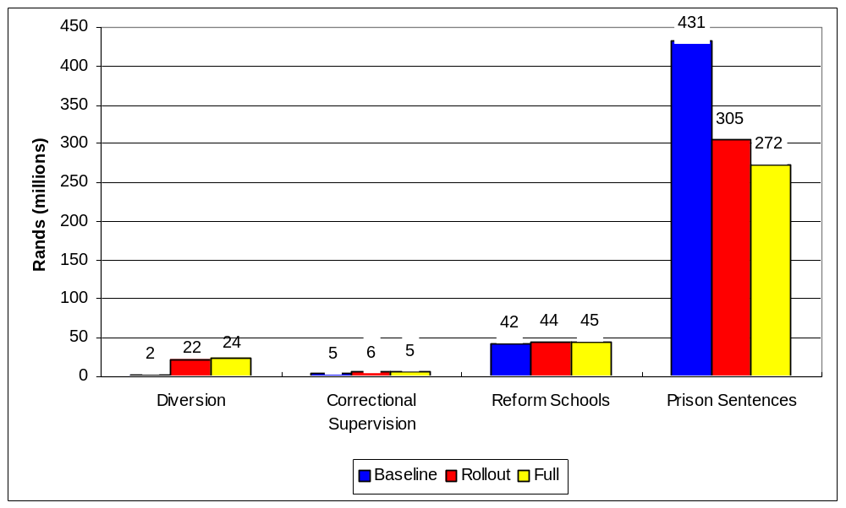
Figure 13: Annual cost of diversion versus annual cost of residential sentences

Furthermore, expenditure on diversion and alternative sentences reaches far more children than expenditure on prison and reform school sentences. Thus not only is its contribution to restorative justice far greater, but the overall benefit it leverages for society is far greater as well. Put very simply, society probably derives greater benefit from spending R1 000 on a two-week diversion course for 5 children, than spending R5 600 keeping the same five children in prison for two weeks. Figure 13 read together with Table 10 shows that this is exactly the kind of trade-off that the new child justice system makes. In the baseline scenario R2 million is spent on diversion and alternative sentences for 10 000 children, and R431 million of prison sentences for 14 200 children. By contrast, in the full scenario R22 million provides diversion and alternative sentences for 60 000 children, and R272 million pays for the sentences of 3 424 children, most of whom have committed serious offences and for whom other sentencing options would not be appropriate (see discussion in section 2.5).
Table 10: Annual number of children diverted versus various sentencing options
Diversion / Sentences | Baseline Scenario | Rollout  Scenario | Full  Scenario
Diversion | 7 860 | 49 373 | 55 530
Alternative Sentences (non-residential) | 2 099 | 5 104 | 5 105
Correctional Supervision | 1 465 | 1 911 | 1 690
Reform Schools | 556 | 587 | 594
Prison Sentences | 14 190 | 5 439 | 3 424
Total | 26 170 | 62 414 | 66 344

Transport costs
Figure 9 shows that transport costs represent about 8 percent of total expenditure on the child justice system. This transport is required to effect arrests, to take children to assessment, home or a place of detention, to take them from where they are being detained to court and back again, often a number of times. In nearly all instances, the police are responsible for providing this service. Figure 9 shows that in the baseline scenario R62 million is spent each year on transporting children in the child justice system, while in the rollout and full scenarios R78 million is spent on transport. Figure 14 shows the distribution of these transport costs across the stages of the child justice system and where cost need to be redistributed between different stages.
Figure 14: Annual cost of transport at different stages in the child justice system
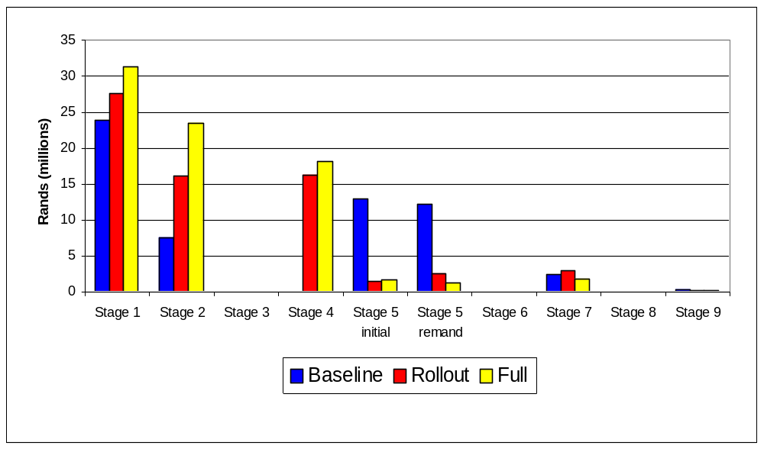
Expenditure on transport in Stage 1 increase between the scenarios due to the additional responsibilities placed on police to trace a child’s parents and ensure they are returned home (where this is appropriate). Expenditure on transport in Stage 2 is expected to increase quite significantly in the rollout and full scenarios due to the increase in the number of children being taken to be assessed. Similarly transport associated with Stage 4 will increase since this is a new aspect of the child justice system. This increase in Stage 4 is largely off-set by the decrease in transport costs in Stage 5:Initial and Stage 5:Remand. The decline in the former case can be attributed directly to the fact that fewer children need to be taken to court, while in the latter stage there are not only fewer children, but because trials are resolved more speedily they have to appear fewer times.

As noted above the use of One-Stop Child Justice Centres could serve to moderate the cost of transport associated with Stages 2, 4 and 5 above, especially in metropolitan areas.

Cost of legal representation
According to the Child Justice Bill a child may request the state to provide legal representation at any stage of the proceedings associated with the criminal justice system and must be advised of this fact by the relevant person in each of the stages. In addition, the Bill requires that after the finalisation of the preliminary inquiry, if a legal representative has not already been appointed, the state must provide the child with legal representation to assist when he or she is to be remanded in detention, when charges are to be instituted in a child justice court that may result in a sentence involving a residential requirement or where a child is at least 10 years but not yet 14 years of age. The Bill notes further that a child may not waive the right to legal representation in the aforementioned instances. In other words, very nearly all children appearing in the child justice court in the new child justice system will have to have legal representation, either their own or provided by the state. This would suggest that legal representation could be a very significant cost to the state in the new child justice system. Table 11 explores the cost of legal representation in Stage 5 of the child justice system in the different scenarios.
Table 11: Estimated annual cost of legal representation in Stage 5 of each scenario
 | Baseline Scenario | Rollout  Scenario | Full  Scenario
Percentage of children assumed to get legal representation from state | 50% | 50% | 75%
Cost of legal representation estimated for each scenario | R15.6m | R10.2m | R11.0m
Cost of providing legal representation to all children appearing in court | R31.2m | R20.3m | R14.7m

The first thing to note is that the expected cost of legal representation would appear to be very significantly less than generally expected. However, the costing method of legal representation used in the CJ-model can only be regarded as giving a very rough estimate of orders of magnitude. Nevertheless it is important to note that the cost of legal representation declines across the scenarios despite the fact that the percentage of children receiving representation increases. As with other cost savings in Stage 5, this must be attributed directly to the fact that significantly fewer cases are brought to court in the full scenario compared with the baseline scenario. Indeed, if legal representation were to become mandatory within the current child justice system it would undoubtedly prove to be very expensive. However, in the new child justice system the costs could be fairly modest.

Cost of monitoring the child justice system
The Child Justice Bill provides for the establishment of a number of institutions tasked with monitoring the child justice system. These include Child Justice Committees in each magisterial district, a Provincial Office for Child Justice for each province, a National Office for Child Justice and a National Committee for Child Justice.

The costs of organising and running the district child justice committees is not expected to be significant, especially given that the Bill expressly provides that no remuneration is attached to attendance or performance of duties for the committee. The Bill requires the MEC for Safety and Security, and the MEC for Welfare in each province to appoint an official to their respective Provincial Offices for Child Justice. These positions will obviously need to be funded, as well as the operations of the offices. According to the Bill the National Office of Child Justice must consist of officials appointed from Justice (X2), Social Development (Welfare)(X1) and Safety and Security (X1). While the respective departments will obviously be responsible for the salaries of the officials they second to the Office, the Department of Justice and Constitutional Development is required to provide the funding for the both the operations of the National Office for Child Justice and the National Committee for Child Justice.

Using the information from the Bill, as well as our experience with monitoring systems, we developed the monitoring structure shown in Table 12. The cost of this proposed monitoring system is shown in Table 13. It is expected that the whole system will cost about R4.81 million per annum with about 70 percent of expenditure taking place in the provinces.
Table 12: Proposed staff structure of monitoring system
 | Director | Deputy -Director | Legal  professional | Admin Officer | Secretary
National Office for Child Justice
Department of Justice | 1 | 1 | 1 | 3 | 2
Department of Safety and Security | 1
Department of Social Development (Welfare) |  | 1
Provincial Offices (per province)
Department of Welfare (provincial) |  | 1 |  | 1
Provincial office for safety and security |  | 1
Total staff requirement | 2 | 20 | 1 | 12 | 2

Table 13: Annual cost of monitoring the child justice system
Expenditure item  (Rands) | Current monitoring system |  | Proposed monitoring system
Expenditure item  (Rands) | National | Provincial | National | Provincial
Personnel Costs | 630 000 | 0 | 1 071 000 | 2 929 500
Premises | 13 000 | 0 | 13 000 | 58 000
Computers (annual maintenance cost) | 6 500 | 0 | 13 000 | 58 000
Computers & programmes (capital investment)¹ | 0 | 0 | 17 000 | 39 000
National Child Justice Committee | 0 | 0 | 77 500
Miscellaneous | 129 000 | 0 | 193 500 | 348 500
Total | 778 500 | 0 | 1 385 000 | 3 433 000
Notes to table
1. Provision is made for a computer system that would cost R260 000, with R80 000 spent by the national office and R20 000 by each of the nine provincial offices. This would include the development of a data-base programme needed to capture and process the data on the child justice system. It is assumed that this expenditure is spread over five years.

Training costs
The new child justice system set out in the Child Justice Bill will involve making significant changes to the way in which children in conflict with the law are currently treated. For the new system to succeed, a substantial investment in training the officials that will be responsible for implementing and operating it needs to be made. It is proposed that a three-year training programme be undertaken, consisting of two sets of courses: one for legal professionals and the other for probation officers and other officials linked to the system. Table 14 gives a breakdown of the minimum number of officials we estimate will need to be trained by this programme.
Table 14: Estimated number of people to be trained
Personnel to be trained in each type of course | National | Provinces | Total
Course 1
Magistrates | 550 | 0 | 550
Prosecutors | 600 | 0 | 600
Legal Representatives | 400 | 0 | 400
Total: Course 1 | 1 550 | 0 | 1 550
Course 2
Clerks of the Court | 1 100 | 0 | 1 100
Policemen | 1 500 | 0 | 1 500
Probation Officers | 5 | 300 | 305
Youth Care Workers | 0 | 0 | 0
Prison Officials | 500 | 0 | 500
Total: Course 2 | 3 105 | 300 | 3 405
Overall Total | 4 655 | 300 | 4 955

Table 15 gives a breakdown of the expected cost of running these courses, as well as the overall cost of the three year training programme. The assumptions and cost variables used to calculate this table are presented in Annexe 2. It is expected that it will be possible to mobilise donor funding to cover a substantial proportion of these costs, although in this costing exercise the cost of training is allocated to each department in proportion to the number of officials trained from that department.
Table 15: Estimated cost of three-year training programme
Expenditure item  (Rands) | Annual Cost of Course 1 | Annual Cost of Course 2 | Total Cost in Initial Year | Total Cost of Three Year Programme
Venues | 64 560 | 86 080 | 150 640 | 451 920
Trainers: Subsistence | 51 648 | 68 864 | 120 512 | 361 536
Trainers: Transport | 32 280 | 43 040 | 75 320 | 225 960
Trainers Consultant Fee | 129 120 | 172 160 | 301 280 | 903 840
Catering | 112 980 | 258 240 | 371 220 | 1 113 660
Administration | 161 400 | 215 200 | 376 600 | 1 129 800
Production costs - course materials | 56 490 | 129 120 | 185 610 | 556 830
Total cost of training courses | 608 478 | 972 704 | 1 581 182 | 4 743 546
Development of training material | 107 600 | 107 600 | 215 200 | 645 600
Total cost of courses plus  materials development | 716 078 | 1 080 304 | 1 796 382 | 5 389 146

Impact on intergovernmental finances and departmental budgets
The implementation of the Child Justice Bill will inevitably impact on the expenditure responsibilities of at least four national departments and two departments in each of the nine provinces, and as a consequence it could also impact on the division of revenue between the national and provincial spheres of government. Table 16 gives a breakdown of total annual expenditure on the child justice system by sphere of government and by department for each of the scenarios.
Table 16: Total annual expenditure on the child justice system by sphere of government and by department
Sphere of Government & Department Responsible for Expenditure  (Rands millions) | Baseline Scenario | Rollout Scenario | Full  Scenario | Difference between Baseline & Full
Total expenditure by national government | 680.99 | 506.88 | 470.11 | -210.88
Department of Justice | 62.55 | 51.96 | 51.04 | -11.51
Department of Correctional Services | 490.56 | 319.76 | 279.05 | -211.51
Department of Safety & Security | 127.49 | 134.68 | 139.50 | 12.01
Department of Social Development (Welfare) | 0.39 | 0.49 | 0.52 | 0.13
Total expenditure by provincial governments | 105.66 | 153.94 | 136.62 | 30.96
Provincial Welfare Departments | 63.75 | 109.76 | 91.85 | 28.10
Provincial Education Departments | 41.91 | 44.18 | 44.77 | 2.86
Unallocated Expenditure | 0.00 | -6.14 | 0.00 | 0.00
Total Expenditure | 786.65 | 654.68 | 606.73 | -179.92

The remainder of this section explores the implications of the information contained in the above table for intergovernmental fiscal relations and for the budgets of the relevant national and provincial departments.

Impact on intergovernmental finances

Impact on the intergovernmental division of revenue
According to Table 16 the consolidated government expenditure on child justice in the baseline scenario is R786.7 million. This represents about 0.3 percent of estimated total government expenditure in 2001/2002. If it is assumed that it will take three years to implement the new child justice system fully, then the estimated consolidated expenditure of R606.7 million for the full scenario will represent just 0.22 percent of the medium term estimate of total government expenditure in 2003/04.

Table 16 gives the percentage breakdown of consolidated government expenditure on the child justice system for each sphere of government by scenario. It is clear that national government’s share of expenditure on the child justice system would drop between the baseline and full scenarios, while that of the provinces’ would increases. This would seem to suggest that some reallocation of resources between these spheres of government would be in order.
Table 17: Percentage breakdown of expenditure between spheres of government
Sphere of Government & Department Responsible for Expenditure | Baseline Scenario | Rollout Scenario | Full  Scenario
National government share of expenditure | 86.5% | 77.4% | 77.5%
Provincial governments share of expenditure | 13.5% | 23.5% | 22.5%
Unallocated Expenditure | 0% | -0.9% | 0%
Total Expenditure | 100% | 100% | 100%

Table 18 shows that indeed such reallocation would in fact be in order. The national sphere of government should realise significant savings (R211 million) from the implementation of the new child justice system, while the provinces are going to have to spend between R33 and R46 million extra. The analysis in the preceding sections highlights the fact that the extra expenditure at the provincial sphere is instrumental in leveraging the savings in the national sphere.

Table 18 also suggests that implementation of the new child justice system may cause provincial expenditure to increase initially (see the rollout scenario) before falling back somewhat. This is because of the more extensive use of places of safety and secures care in the rollout scenario relative to the full scenario. It is expected that as the new justice system begins functioning the preliminary inquiry will become more efficient thus reducing the need for detention and reducing the number of children referred to trial.
Table 18: Potential annual saving for each sphere of government
Sphere of Government & Department Responsible for Expenditure  (Rands millions) | Baseline Scenario | Rollout Scenario | Full  Scenario
Total expenditure by national government | 680.99 | 506.88 | 470.11
Potential increase (+) or decrease (-) in expenditure relative to the baseline scenario |  | -174.11 | -210.88
Potential increase (+) or decrease (-) in expenditure relative to the rollout scenario |  |  | -36.77
Total expenditure by provincial governments | 105.66 | 153.94 | 136.62
Potential increase (+) or decrease (-) in expenditure relative to the baseline scenario |  | +48.28 | +30.96
Potential increase (+) or decrease (-) in expenditure relative to the rollout scenario |  |  | -17.04
Unallocated Expenditure | 0.00 | -6.14 | 0.00
Total Expenditure | 786.65 | 654.68 | 606.73
Total potential increase (+) or decrease (-) in expenditure relative to the baseline scenario | 0 | -131.97 | -179.92

Table 18 suggests that the implementation of the full scenario could save the whole of government about R180 million each year relative to what it is estimated to currently spend on the child justice system in the baseline scenario. This represents a potential saving of about 23 percent. The saving to the national sphere of government will be about R211 million which represents a potential saving of about 31 percent of the national spheres current estimated expenditure on the child justice system. By contrast expenditure in the provincial sphere will have to increase by at least R31 million or by 30 percent. Since the provinces play an important role in realising the savings at the national sphere, some reallocation of the benefits to them should be regarded as necessary so that the savings can in fact be realised.

Such a reallocation could be achieved in two ways:

(a) Accommodation in the vertical split
The vertical division of nationally collected revenue could be adjusted in favour of the provincial share in recognition that the provinces will need to spend more on the child justice system to enable the national government to realise the above-mentioned savings. While this would be the technically correct approach to ensuring an unfunded mandate is not imposed on the provinces, it could be argued that such an adjustment would be very marginal in the context of the vertical split. In fact, the change would be barely noticeable and would tend to be dissipated among the many other expenditure priorities of provinces. In addition, such an adjustment based on a very specific cost would go against government’s current approach to the vertical split, which is to regard it as the result of a political judgement, rather than the product of any detailed costing of the responsibilities of the respective spheres of government.

(b) Use of conditional grants
The national government could use conditional grants to reallocate funds to the provinces specifically for funding elements of the child justice system. Depending on how the grants are structured, the potential advantages of this approach include:
- It enables the national government to leverage certain actions (or funds) from provincial governments, for instance a condition of the grants may be that they must be used to employ probation officers, pay for diversion, the monitoring of child justice or contribute to the running costs of secure care facilities.
- It enables the national government to co-ordinate the implementation of different components of the new child justice system. The grants may be linked to developing very specific facilities that are needed to get the child justice system functioning efficiently in a particular area, for instance a One-Stop Child Justice Centre in a given metropolitan area.
- It can be used to make explicit the link between increased expenditure at the front end of the child justice system (e.g. on assessment) to savings realised later in the system (e.g. on imprisonment).
- It can be used to compensate provinces that provide services linked to the child justice system that are used or should be used by more than one province. Reform schools are a case in point.

The downside of conditional grants is that they tend to undermine provincial governments’ freedom (and responsibility) to allocate resources according to provincial priorities. This conflict between national and provincial priorities is by no means unique to the criminal justice system. It is exactly because this conflict exists that conditional grants are an important component of the intergovernmental system. They enable the national government to finance the implementation of important national policies by provincial governments. Another risk of conditional grants is that they can fail dismally in their objective if the conditions (including performance indicators) are not clearly spelt out and actively monitored by the relevant national department.

The risk of unfunded mandates on provinces
A perennial concern of provincial governments (particularly of provincial treasuries) is the impact that new legislation passed by national government will have on provincial expenditure responsibilities. Where national legislation imposes new expenditure responsibilities on provinces, but the division of revenue between the national and provincial spheres of government is not adjusted accordingly, such responsibilities are usually referred to as unfunded mandates, i.e. the provinces are mandated to do something but do not receive the funds to do so.

Various national and provincial government officials interviewed for this research expressed the fear that the Child Justice Bill would impose unfunded mandates on the provinces, more particularly on the provincial welfare departments which are responsible for providing probation officers, places of safety, and secure care facilities, as well as diversion services. That the Bill will impact on the expenditure responsibilities of provinces is beyond doubt. Table 16 shows that the Bill will in all likelihood impose additional expenditure responsibilities on provincial welfare and education departments. However, whether these additional responsibilities can be regarded as unfunded mandates is doubtful.

Firstly, in terms of Section 76 the Constitution all Bills affecting provinces have to be considered and passed by both the National Assembly and the National Council of Provinces (NCOP). This includes all Bills dealing with matters listed in Schedule 4 of the Constitution. The provinces acting through the NCOP, therefore, have an opportunity to amend or reject all Bills that impose expenditure responsibilities on them. However, if the NCOP passes a Bill it is expressing its agreement with all the Bill’s details, including the expenditure responsibilities it imposes on the provinces. Therefore if the provinces feel they cannot afford a particular Bill before the NCOP they should instruct their delegation to amend it appropriately or not to pass it. If the NCOP passes a Bill, the provinces cannot complain about it imposing unfunded mandates. The provinces can only legitimately claim that legislation imposes an unfunded mandate on them where the NCOP has rejected a Bill and the National Assembly has exercised its two-thirds override option. However, this is unlikely to happen in practice. The Child Justice Bill will be a so-called Section 76 Bill as several of its provisions fall within the functional areas listed in Schedule 4. It will therefore have to be tabled in the NCOP, which will give the provinces the opportunity to consider the expenditure responsibilities the Bill imposes on them and either agree to them or amend the Bill appropriately.

Secondly, the Division of Revenue Bill which deals with the annual division of national revenue between the different spheres of government has to be tabled in the National Assembly. Once the National Assembly passes it, the Bill must be referred to the NCOP. This gives the provinces an opportunity to evaluate whether the allocation of resources proposed by the Division of Revenue Bill provides sufficient funds for them to fulfil their expenditure responsibilities. If it does not they should instruct their delegations to either pass it with amendments or reject it. If the NCOP passes the Division of Revenue Bill with amendments or rejects it, the Bill has to be referred back to the National Assembly and passed again. Only when the NCOP rejects the Bill and the National Assembly exercises its override option can the provinces legitimately claim that they are being ‘under funded’. However, even then it would be difficult for a province to claim that one area of responsibility is funded and another not. Such a statement would simply reflect the provinces’ priorities given the budget constraint, rather than serve to identify an unfunded mandate. The real question is: Do the provinces regard the responsibilities outlined in the Child Justice Bill to be important enough allocate funds to?

Thirdly, to claim that a particular responsibility is an unfunded mandate is often nothing more than an attempt to game the budget system with a view to getting access to more resources. Experience with both departments and the provinces suggests that the higher the public profile of the particular expenditure responsibility the more likely the claim that it is an ‘unfunded mandate’. The logic is that high profile expenditure responsibilities will generate the public and media attention needed to pressurise politicians and the various treasuries into allocating additional resources to the department or province as the case may be. Given the profile of the Child Justice Bill, and the general importance of the criminal justice system, spending agencies and provinces may consider using it to try and increase their respective budget allocations. However, as Table 16 shows some funds should be allocated to the provinces to enable them to implement the Child Justice Bill properly.

However, given that none of the legislation placed before Parliament to date has been properly costed, the NCOP has not had access to information to evaluate whether a particular Bill will impose additional expenditure responsibilities on the provinces, and whether provinces have the necessary funds available or are being allocated the necessary funds by the Division of Revenue. Indeed the Division of Revenue Bill itself is sadly lacking in costing information to indicate on what basis the revenue is being allocated between the different spheres of government. The debate around unfunded mandates has therefore been taking place in an information vacuum. It is precisely for this reason that the kind of costing done for this report is so important: it provides the information that Parliament, and more especially the NCOP, needs to evaluate the financial implications of passing this particular piece of legislation. Ideally, all legislation before Parliament should be costed using technically sound methodologies.

As noted in section 1.1, section 35 of the Public Finance Management Act requires that

Draft national legislation that assigns an additional function or power to, or imposes any other obligation on, a provincial government, must, in a memorandum that must be introduced in Parliament with that legislation, give a projection of the financial implications of that function, power or obligation to the province.

Since the Child Justice Bill clearly does impose certain obligations on provincial education and provincial welfare departments, the Department of Justice and Constitutional Development (as the main sponsor of this Bill) will need to prepare the requisite memorandum. As noted previously it is envisaged that the information from this costing exercise will assist with this.

Impact on departmental budgets
Table 16 gives a breakdown of the total annual expenditure on the child justice system by sphere of government and by department. Here we focus more closely on the expenditure responsibilities of each department. It must be emphasised at the outset of this analysis that these expenditure figures give only a broad indication of levels and trends. The breakdown of the expenditures into different cost items must also be treated with care.

Department of Justice and Constitutional Development
The Department of Justice and Constitutional Development’s role within the child justice system can be divided into three components:
- the provision of the physical infrastructure, mainly the courts, required to administer justice;
- the provision of personnel in the form of prosecutors, magistrates, clerks of the court interpreters and so forth; and
- the provision of legal aid.

The CJ-model focuses on costs arising from the use of prosecutors’ and magistrates’ time and from legal aid, as well as the costs of the use of ‘appropriate adults’ to support children standing trial. Other components were not costed as they are either not seen as a constraint in the current system compared to the new system or because they are a fixed cost of the overall system of justice.
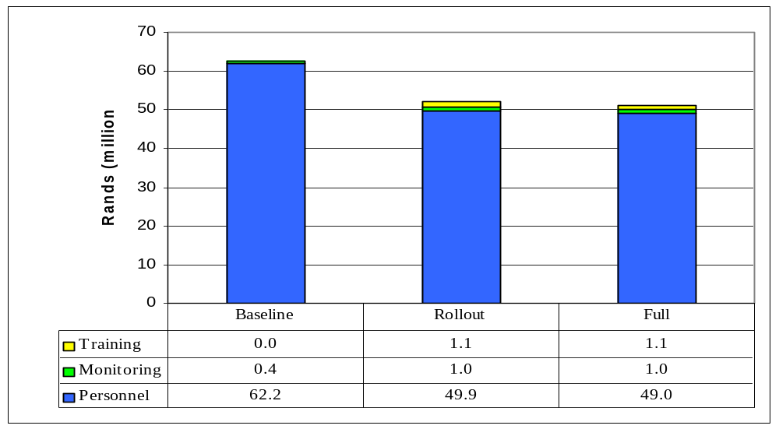
Figure 15: Total annual expenditure by the Department of Justice on the child justice system in each scenario

Figure 15 shows that implementing the Child Justice Bill is expected to save the Department of Justice about R13.2 million in personnel expenditure. The greatest savings are in the area of legal representation, with smaller savings in magistrates’ and prosecutors’ time. There will be some additional expenditure required for ‘appropriate adults’ but within the context of the overall system this is relatively minor. The Department of Justice’s contribution to the Office of Child Justice will increase its current expenditure on monitoring child justice by about R600 000.

Figure 16 shows that in order to successfully implement the new child justice system the Department of Justice will have to reallocate substantial resources (primarily magistrates’ and prosecutors’ time) from the trial stage of the system (Stage 5) to the preliminary inquiry (Stage 4). If this reallocation does not occur, or only occurs partially, the trial process will continue to incur the high costs shown. Other departments will also continue to incur high costs as a result, notably transport, detention and imprisonment costs.

The importance of the Department of Justice’s commitment to the preliminary inquiry process cannot be over emphasised. It is the key to ensuring children are diverted from the court system and are kept out of detention in prison. It also plays an important role in reducing the number of prison sentences imposed on children.
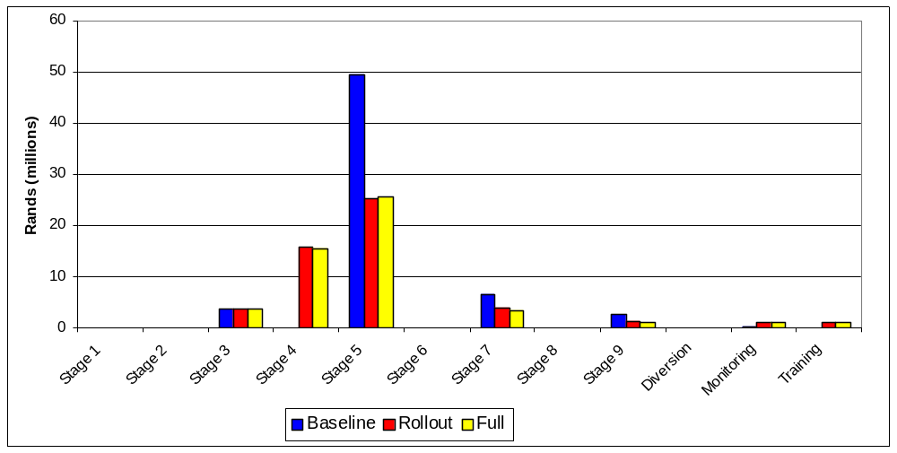
Figure 16: Annual expenditure by the Department of Justice by stage for each scenario

Department of Correctional Services
The Department of Correctional Services’ role in the child justice system is limited to providing detention and sentencing services. Given that a key aim of the new child justice system is to steer children away from the prisons, the Department is likely to realise substantial savings from successful implementation of the Child Justice Bill.
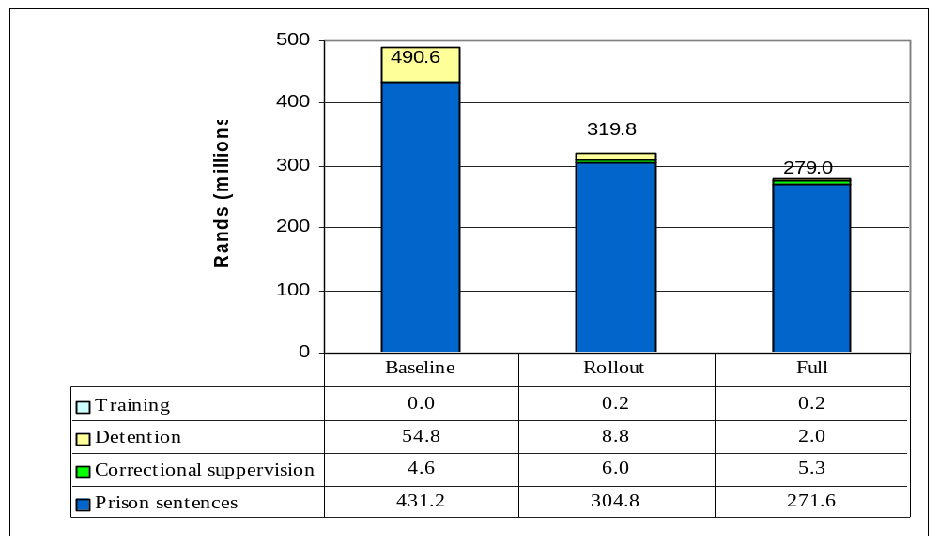
Figure 17: Total annual expenditure by the Department of Correctional Services on the child justice system in each scenario

Of all the areas of expenditure in the child justice system, the CJ-model is probably able to cost those incurred by the Department of Correctional Services most accurately. In 2001/2001 the Department budgeted to spend just over R3.6 billion on detention and imprisonment. It is estimated that about R486 million or 13 percent of this was spent on incarcerating children (see baseline scenario in Figure 17). It is envisaged that the implementation of the new child justice system could reduce this by some R212 million or by almost 43 percent. A substantial proportion of these savings would come from very nearly eliminating the use of prisons for detaining children awaiting trial and sentence. Unlike savings in most other departments, we expect it to be possible to translate a substantial proportion of these savings into real cuts to the Department’s budget. This would release resources for reallocation, say in the form of conditional grants to provincial welfare departments to pay for secure care and diversion.

Figure 18: Annual expenditure by the Department of Correctional Services by stage for each scenario
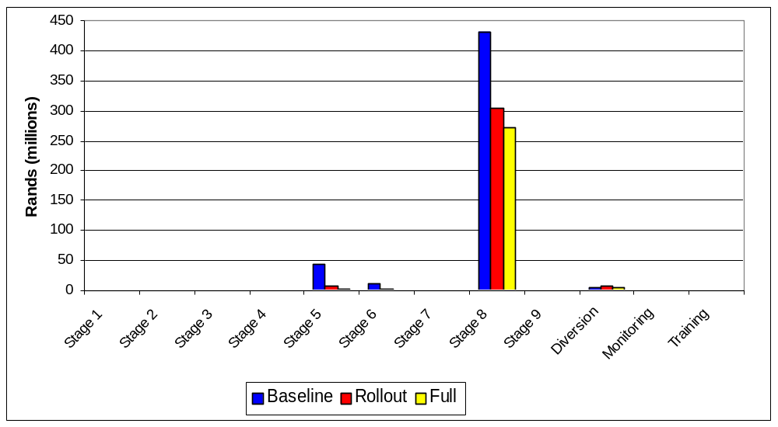
Figure 18 shows that in the baseline scenario, 88 percent of all expenditure by the Department of Correctional Services on the child justice system is associated with providing for children serving prison sentences (Stage 8). Most of the remainder goes towards detaining children awaiting trial or sentence (Stages 5 and 6). In the full scenario almost 97 percent goes towards prison sentences. As noted in section 3.1.3 around 75 percent of the prison sentences in the full scenario would be for sentences of longer than two years, whereas in the baseline scenario more than 80 percent of sentences are for periods of less than two years. In other words prison sentences would only be used as a sentence of last resort and in instances where the seriousness of the offence warrants it.

Department of Safety and Security
The Department of Safety and Security or rather the South African Polices Service (SAPS) is the front line of the child justice system. The way in which the police carry out their duties with regards to the maintenance of law and order plays an important role in determining how of the many children who commit offences actually enter the child justice system and whether, cases actually proceed beyond the police station. As noted in Table 3 about 60 percent of the estimated 330 000 cases attributed to children go untraced or are unfounded. If current efforts to improve policing were to reduce the number of unsolved cases substantially, in the context of the current child justice system, the result would simply be larger court backlogs, longer delays in trials and more children being detained in police cells and prison. It is therefore essential to get the child justice system working so that it can complement efforts to improve policing.

The SAPS interface with the child justice system falls into at least four categories, namely the crime prevention, detention, detective services and transport/escort services. The CJ-model concentrates on costing the detention and transport/escort services as these are an integral part of the functioning of the child justice system. The other two are no less important to the overall success of the system, but are regarded as part of SAPS’ broader policing responsibilities and are therefore not costed here.
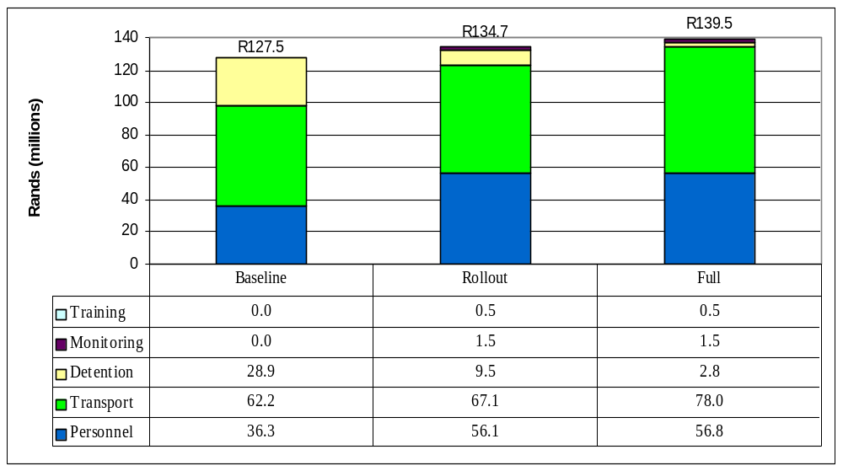
Figure 19: Total annual expenditure by the Department of Safety and Security on the child justice system in each scenario

Figure 19 shows that the implementation of the new child justice system will cut expenditure on detaining children in police cells from about R29 million in the baseline scenario to just R1.5 million in the full scenario. It is envisaged that this will be achieved by enabling the police to take arrested children to assessment as soon after arrest as possible, if not immediately. From there they would be released into the custody of a responsible adult (usually a parent), referred to a place of safety, detained in a secure care facility, in a police cell or in prison or referred immediately to a preliminary inquiry. These savings on detention offset increases in expenditure in other areas, notably personnel and transport.

Figure 19 shows that the Department of Safety and Security will in all likelihood need to increase its expenditure on both personnel and transport to ensure the successful implementation of the Child Justice Bill. It is estimated that personnel expenditure will need to increase from R36.3 million in the baseline scenario to R56.8 million in the full scenario. This is an increase of about 55 percent. Most of the increase in personnel expenditure can be attributed to the responsibilities the Child Justice Bill places on officers that arrest a child, including taking the child home where appropriate.

Note that in the full scenario, about R300 000 of the personnel expenditure is for child finders. The experience with using child finders to locate children’s homes and parents has been very positive and significantly reduces the likelihood of children being detained in police cells unnecessarily. Not only is this in the interests of the children concerned, but it also saves detention costs.

It is estimated that expenditure on transport will increase from R62.2 million to R78 million as a result of increased responsibilities on the police to take children to and from different venues in the child justice system. This is an increase of about 25 percent. As noted previously the establishment of One-Stop Child Justice Centres will go a long way to reduce the need for such escort services, especially in metropolitan areas.
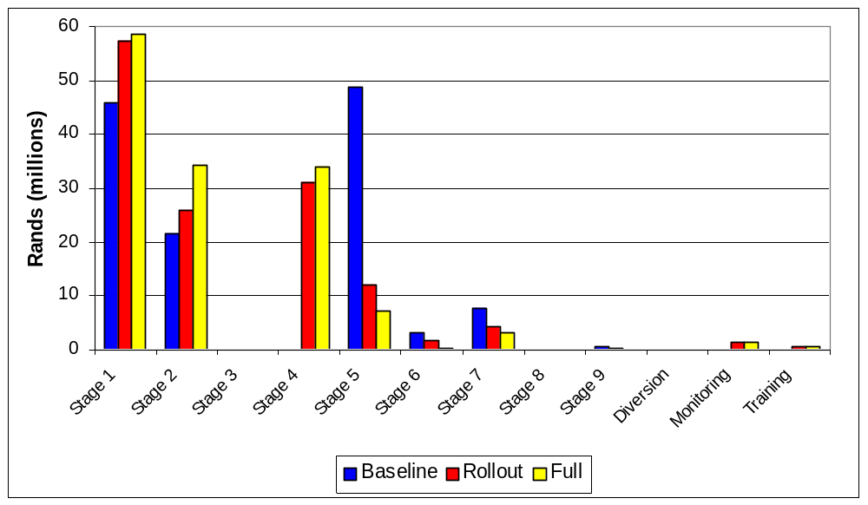
Figure 20: Annual expenditure by the Department of Safety and Security by stage for each scenario

Figure 20 shows that the Department of Safety and Security’s cost will increase in Stages 1 and 2. This is because the police bear primary responsibility for transporting children from the place of arrest to the police station, to assessment, home or to a detention facility. What stands out is the fact that in Stage 5 police costs are expected to fall by more than R41 million. This is directly due to the reduction in the number of children being tried in the full scenario, as well as the fact that trials are shorter thus requiring fewer remands.

In addition section 36(5) of the Child Justice Bill does away with the current 14-day remand rule (whereby a child in detention has to be brought before a magistrate every 14-days) and replaces it with a 30-day remand rule if the child is detained in prison and a 60-day remand rule if the child is detained in another residential facility (such as secure care). Section 81 of the Child Justice Bill also limits the amount of time a child may be detained under normal circumstances to six months. Both these provisions serve to reduce the amount of transport the police need to provide in relation to children in Stages 5, 6 and 7.

Department of Social Development and provincial welfare departments
Unlike other national departments, the Department of Social Development’s role is restricted to policy development, implementation co-ordination and monitoring. Although section 50(1) of the Child Justice Bill states that ‘the Minister of Welfare and Population Development’ is responsible for the development of suitable diversion options’, in our costing we have taken this to mean that the Department of Social Development will facilitate and co-ordinate the development of diversion options rather than undertake the funding of such diversion options. In line with the current division of responsibilities we assume that the provincial welfare departments will continue funding diversion.

By contrast the nine provincial welfare departments are responsible for the welfare sector’s day-to-day operational activities related to the child justice system. They provide the probation officers or social workers that carry out assessments and pre-sentence reports. They ensure there are youth care workers that look after children’s physical needs at the assessment centres. They are also responsible for places of safety and the provision of secure care facilities. In addition, the provincial welfare departments provide much of the funding for organisations that do diversion, such as NICRO.

The expenditure implications of this division of responsibilities between the Department of Social Development and the provincial welfare departments is highlighted in Figure 21.
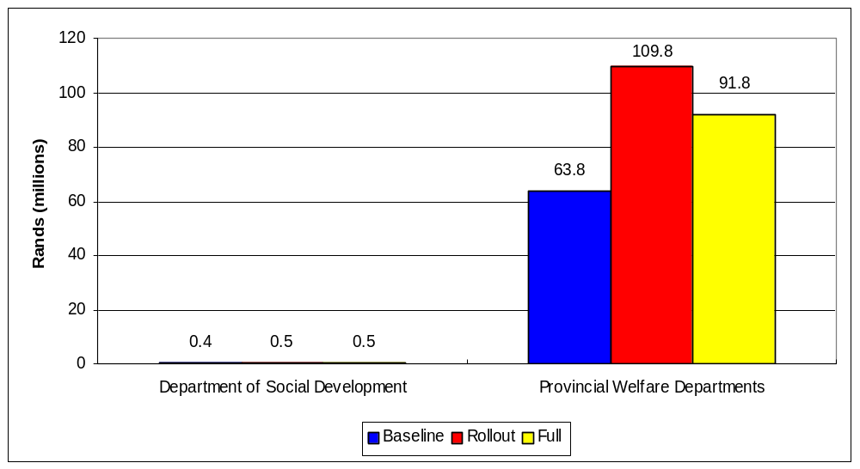
Figure 21: Total annual expenditure by national and provincial welfare departments on the child justice system in each scenario

This figure shows that the national Department of Social Development spends less than R1 million in all three scenarios. Nearly all of this can be attributed to monitoring costs (note that this does not take into account the funds that were made available to the Inter-Ministerial Committee on Young People at Risk). In the full scenario, it reflects the Department of Social Development’s share of expenditure on the Office of Child Justice.

By contrast, the provincial welfare departments are estimated to spend about R64 million in total on the current child justice system. Figure 21 shows that total expenditure by provincial welfare departments on the child justice system is set to increase to R92 million in the full scenario. Note that expenditure in the rollout scenario is expected to be higher than in the full scenario due to the fact that more children will need to be detained in secure care facilities (as opposed to prison) while the preliminary inquiry and diversion systems are established. Managing this transition is likely to be difficult, and given the lack of secure care facilities it is likely that many children will still be detained in prisons.

A further caveat is that the situation may differ substantially across provinces. Those that currently have well-developed systems for servicing the child justice system may effect savings, while those with underdeveloped system will obviously have to spend more. This study did not examine the possible impacts for individual provinces of implementing the Child Justice Bill, although an initial analysis would suggest that those provinces with urban populations will need to spend more on implementing the Bill than rural provinces (see discussion of Table 19).

Figure 22 examines the breakdown of expenditures by the welfare sector (i.e. national and provincial departments) in each of the scenarios. Five things stand out:

Firstly, personnel costs associated with the child justice system increase more than threefold: from about R2.4 million in the baseline scenario to R9.1 million in the full scenario. This is directly related to the increased demand for the assessment services of probation officers, as they will be expected to handle nearly all cases where children come into conflict with the law. They will also be expected to participate in the preliminary inquiry, which is a new responsibility, and play a role in developing diversion opportunities and monitoring such programmes.

Secondly, the child justice system’s demand for the services of places of safety is expected to fall significantly. Even though the demand for such services increases in the earlier stages of the child justice system this is more than offset by lower demand in the trial and pre-sentencing stages. It is estimated that expenditure on these services could fall by almost 40 percent: from R29.5 million in the baseline scenario to R18 million in the full scenario. Note, however, that this does not mean that overall demand for places of safety services will fall at all. This costing does not take into consideration decisions that the children’s court may make with regard to destitute children, even though the children may have been referred to such a court from the child justice system.

Thirdly, it is expected that the demand for secure care facilities is likely to increase significantly – from R29 million in the baseline scenario to R35 million in the full scenario. This is largely due to the expectation that these facilities will be used to detain children, instead of in prison. In addition, the 60-day remand rule applicable to children detained in such facilities is likely to increase the average length of stay as it will take longer for their trails to be resolved.

Fourthly, expenditure on diversion will have to increase more than ten-fold, from R2 million in the baseline scenario to over R24 million in the full scenario. This is essential if the aims of the Child Justice Bill are to be achieved. Within the system as a whole R24 million is not a substantial amount especially when compared with the savings it leverages (see section 3.5.1). The problem will be to phase this increased expenditure so as to enable the savings in other areas to be realised. Conditional grants from the national Department of Social Development to the different provinces may facilitate this process.
Fifthly, it is expected that the provincial welfare departments are required to contribute actively to the monitoring of the child justice system (see section 3.8). As discussed above this will entail setting up systems at the provincial level to gather and feed information upwards to the national monitoring system. Each province is likely to have to allocate R2 million for this purpose.
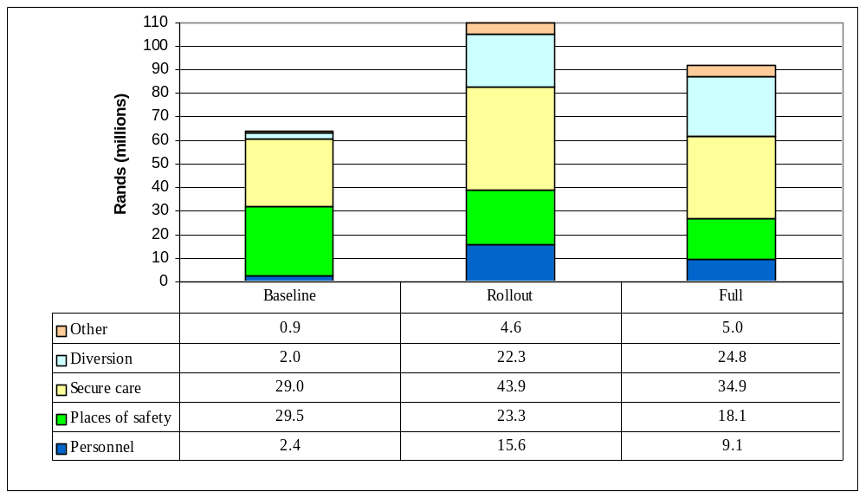
Figure 22: Total annual expenditure by the provincial departments of welfare on the child justice system in each scenario

Figure 23 shows how total expenditure by provincial welfare departments is expected to be spread across the different stages of the child justice system. It confirms the above noted expenditure shifts.
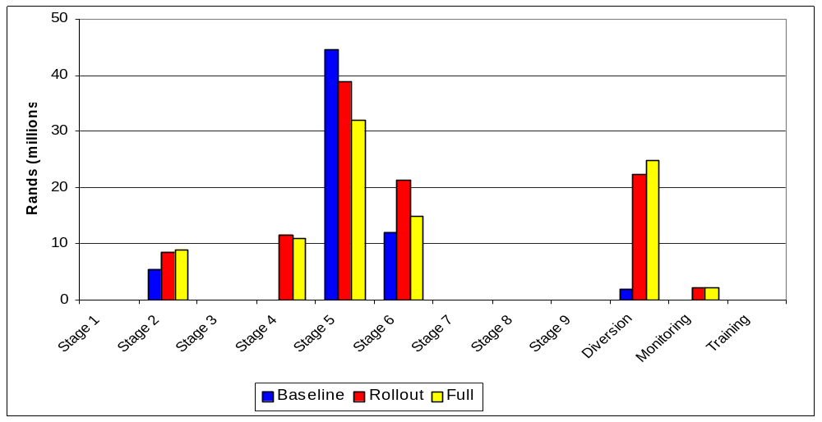
Figure 23: Annual expenditure by provincial welfare departments by stage for each scenario

Table 19 gives a provincial breakdown of the estimated annual expenditure by the welfare departments in each of the provinces. Current patterns of expenditure by the different provincial welfare departments may well deviate from those shown below. The point of the table is to set a baseline against which the expenditure across the provinces can be measured. What is notable is that provinces with predominantly urban populations can be expected to spend far more on the child justice system. For instance, Gauteng which has only 13 percent of the children between 7 and 18 years, is estimated to spend R15 million on the current child justice system. This is 23 percent of the combined expenditure of the provincial welfare departments. On the other hand, the Northern Province is home to 15 percent of the country’s children between 7 and 18 years should be spending about R2.1 million or just over 3 percent of the R64 million. This clear urban bias in expenditures reflects the urban bias in criminality generally, but particularly amongst children.
Table 19: Breakdown of annual expenditure on welfare by province
Provinces  (Rands millions) | Baseline Scenario | Rollout Scenario | Full  Scenario | Difference between Baseline & Full
Eastern Cape | 8.54 | 14.32 | 12.57 | +4.03
Free State | 5.64 | 10.07 | 8.4 | +2.76
Gauteng | 15.51 | 24.35 | 22.37 | +6.86
Kwa-Zulu Natal | 12.17 | 20.22 | 17.7 | +5.53
Mpumalanga | 3.36 | 6.17 | 5.1 | +1.74
Northern Cape | 1.99 | 3.72 | 3.12 | +1.13
Northern Province | 2.1 | 4.16 | 3.28 | +1.18
North West | 4.97 | 9.03 | 7.43 | +2.46
Western Cape | 9.48 | 16.03 | 13.92 | +4.44
Total of all provinces | 63.75 | 108.06 | 93.89 | +30.14

A further point to note is that provinces with predominantly rural populations may experience a temporary increase in expenditures during the implementation phases of the child justice system; however, the evidence for this is not very strong. At a conceptual level such an increase should be expected as the rural areas generally receive very low levels of services at present. Implementing the Child Justice Bill would lead to improved levels of service which would cost more and which would only be offset by savings in other areas later on in the implementation process.

Provincial education departments
Table 20 gives an estimate of the total expenditure by the provincial education departments on reform schools by scenario. Given the current distribution of the nine reform schools most of this expenditure will be the responsibility of the Western Cape (six schools), KwaZulu Natal (two schools) and Mpumalanga (one school) provincial governments. However, given that these facilities are used as sentencing options by courts in all provinces this is proving to be problematic (see discussion in section 5.8).

Table 20 suggests that there is not likely to be much change in the use of these facilities between the baseline and full scenario.
Table 20: Estimated annual expenditure on reform schools by scenario
(Rands millions) | Baseline Scenario | Rollout Scenario | Full  Scenario
Provincial Education Departments | 41.91 | 44.18 | 44.77

The most important point of the above table is that there does not seem to be a pressing need to build any new reform schools. What is needed is a system of referrals to ensure children from outside the Western Cape can use the existing facilities. Obviously, in the medium term it would be desirable to build new facilities in under-serviced areas, particularly in Gauteng. However given existing budget constraints this is probably not an immediate priority.

Implementation Strategy
The Child Justice Bill not only introduces a number of fundamental changes to the current child justice system, it also sketches a vision towards which the current system must move. The focus of the discussion in this section is on developing a strategy to implement the key elements of this longer-term vision.

Political and managerial buy-in
The need for political and managerial buy-in cannot be overemphasised. Cabinet should give its full support to the Child Justice Bill and take collective responsibility for its implementation once it is passed by Parliament. The respective ministers must make it clear to their respective accounting officers that the implementation of the Bill is a government priority. This should be reflected in their performance contracts, as well as in the various departmental strategic plans and operational plans. This support also needs to be reflected in the reallocation of resources between the different components of the system. This reallocation of resources should be planned and recorded in the various departments’ medium term expenditure frameworks. Indeed each department with a role to play in the child justice system should already be considering how this Bill is likely to impact on their budgets in 2002/2003, so that as soon as the Bill is passed implementation can get off to a flying start, as opposed to having to wait for the next budget year to get access to or reallocate resources.

The Cabinet’s support for the proposed new system of child justice also needs to be reflected in backing those implementing the Bill when difficulties arise. For instance, the Bill may be seen by the public as being too lenient on children in conflict with the law. If this becomes an issue the relevant Cabinet Ministers need to give explicit support to the objectives the Bill seeks to realise. They need to manage the risk that the transition process is likely to entail.

At the managerial level the Bill must not be seen as just another item on the parliamentary agenda that needs some attention. The management of the five departments must make the implementation of the Bill a key objective. The preceding analysis shows that managers have every reason to do so, given that it offers real opportunities to realise enormous costs savings and improvements in the effectiveness of expenditure on the child justice system.

A systemic approach
The implementation of the changes proposed by the Child Justice Bill need to be approached systemically. The integrated, interdependent nature of the different processes needs to be fully understood. The CJ-model goes a long way towards highlighting these linkages at a macro-level, but a lot more work needs to be done to develop an understanding of how the child justice system functions in different localities. While this calls for an area specific approach, sight must not be lost of the fact that different components of the system need to be designed together in order to ensure both effective and efficient operation. This implies taking advantage of economies of scale where they exist. So, for instance, while courts serve particular magisterial districts, it may be more appropriate for a One-Stop Justice Centre to serve a number of districts. Similarly places of safety and secure care facilities may service even larger regions than merely the provinces in which they are located. Reform schools may serve a number of provinces. And the monitoring unit will provide a service to all the different components of the system in the country. Each of these components can only function effectively if all other components are also working.

The systemic approach demands that the five departments involved in the child justice system need to:
1. Develop a common set of strategic objectives for the child justice system and identify the core role of each of the departments in the system;
2. Develop a single, integrated strategic plan for realising the above objectives. This plan must be specific about what needs to be done, what inputs are required and who should supply them, and indicate how success is to be measured (preferably in terms of outputs). It must also allocate responsibilities to departments in an unambiguous manner;
3. Jointly cost and budget for the different components of the child justice system, giving explicit recognition to the need to sequence certain expenditures,
4. Co-ordinate the sequencing of the implementation of the strategic plan; and
5. Jointly monitor the management, outputs and outcomes of the child justice system.

While co-ordination and co-operation are crucial to success, this must not be allowed to lead to a situation where no-one takes responsibility. For this reason, it cannot be over emphasised that the strategic plan must define clear objectives in terms of outputs and allocate responsibility for achieving those outputs. There should be joint planning, but singular implementation, and joint monitoring.

Big bang’ vs ‘Roll-out’
Note that a systemic approach is not synonymous with a “big bang” approach where all components of the system are restructured at the same time. The big bang approach could severely compromise service delivery – the challenge is therefore to change the child justice system without further compromising its current performance.

A systemic approach entails conceptualisation of the entire project first, based on principles which ensure systemic coherence. To a large extent the Child Justice Bill seems to do this. The challenge now is to divide the actual implementation of the Bill into a number of phases. Even though the implementation is phased and sequenced, the Bill must be seen as providing the underlying logic between the constituent parts of the child justice system. This is in contrast to an ad hoc incremental approach, which makes gradual changes at the margin, but which may lack systemic coherence. An ad hoc approach also tends to focus on the symptoms of underlying problems rather than the root causes of the problems. For instance, the holding of children in police cells may be identified as a major problem in the current child justice system. One solution may be to make it more difficult for police to hold children in custody after arrest. However, this would tend to undermine good policing. A systemic solution would be to ensure that the police are able to refer the children they arrest to the next stage in the child justice system knowing that they will be properly processed. The solution would therefore be built around strengthening the link between arrests and assessment, eliminating delays and therefore the need to hold children in police cells.

A systemic approach to the changes proposed by the Child Justice Bill are likely to require quite a long roll-out period (at least three years). This means that a project management approach is absolutely essential. More importantly the implementation plan will have to be reviewed periodically in the light of the changing circumstances within which the various departments operate and actual progress in implementation. This, however, is not an invitation for further ‘planning induced’ delays. The project management team must be focussed, and structured in such a way that it has to deliver to a strict timetable. The team should also be interdepartmental and include provincial representatives as well so as to ensure proper co-ordination amongst national departments, as well as between the national and provincial spheres of government.

Developing capacity
Capacity is an important consideration in transformation (human capacity, financial capacity, information technology etc). But current capacity should not dictate the destination that the Child Justice Bill wishes to achieve. In other words, the fact that certain competencies, facilities or resources are not currently available should not determine what is regarded to be achievable at some future date, since the necessary capacity can be developed over time. Current capacity does however influence the trajectory of the implementation strategy to achieve the specified objective. The strategy needs to synchronise capacity building and training in the transition from the current situation to the destination point. Therefore, while training and capacity building are important they must not be allowed to hold the implementation process hostage. Rather, the training process should be used to complement and strengthen changes that are being implemented. In other words the process of training has to respond to the needs of the system, rather than training being allowed to set the pace of change.

This approach to training and capacity-building is based on the view that people will seek to invest time ‘learning how the new system works’ only if that system is a reality in their lives. So long as the implementation of the system is being ‘planned’ so people will only ‘plan’ to learn how it works some time in the future. With this in mind, it is useful to set firm dates for the implementation of different components (such as the preliminary inquiry) and then to ensure that training is available in the period just prior to implementation. All this means is that training must be co-ordinated with the overall implementation.

Ensuring effective monitoring
Putting in place an effective monitoring system is going to be crucial both for the successful implementation of the Child Justice Bill and the ongoing functioning of the child justice system more generally. A risk of monitoring exercise is that they can collect a wealth of information that does not inform management decisions and does not feed back into evaluation and planning processes. Often it simply accumulates in an unknown office and goes absolutely nowhere. Setting up Key Performance Indicators or measurable objectives for each component or stage in the child justice system must be integral to the development of the strategic plan. These indicators must:
- Relate directly to the objectives of the Child Justice Bill, and the performance of the child justice system;
- Be specific, measurable, achievable, relevant and time bound (i.e. they should be SMART objectives)
- They should also be accessible (easily understood);
- Have managerial relevance;
- Be limited in number; and
- Focus on both the quantitative and qualitative performance of the system.

As noted in section 3.8, the Child Justice Bill creates sufficient ‘civil society’ oversight mechanisms with the district child justice committees and the national committee for child justice. The proposed provincial offices and National Office for Child Justice are a necessary and welcome component of the Bill. It is essential that these institutions are properly funded and officials with a real interest in child justice issues are appointed to drive the setting up of appropriate monitoring and reporting systems. While it is important to put systems in place to gather information, it is equally important to build regular reporting procedures so that the information is fed into, and informs, managerial decision-making. This needs to be an explicit objective in the design of the monitoring system. In the case of the child justice system, it can play an exceptionally important role in binding the different components of the system together. The provincial welfare departments will want to know how many children are being arrested so that they can budget for assessment and diversion. The Department of Justice will want to know what diversion options are available so as to ensure opportunities to get children out of the system are effectively used. The Department of Correctional Services will want information on sentencing trends so that it can prepare facilities to accommodate children sentenced to prison and so forth. Ensuring effective communication between different departments is going to be an important function of these offices.

Focussing on areas of maximum impact
At a more practical level, the preceding analysis shows that the Child Justice Bill is likely to have maximum impact on the functioning of the child justice system if implemented in metropolitan areas. We therefore recommend that the implementation process start in metropolitan areas and then roll out to large urban centres and later small towns/rural areas. It is expected that this sequencing will allow the savings that are generated in getting the system working in metropolitan areas to finance the upgrading of the system in small towns/rural areas where more investment in infrastructure is likely to be required.

One-Stop Justice Centres
One of the ways of ensuring maximum impact is through the use of One-Stop Child Justice Centres, such as the Stepping Stones Centre in Port Elizabeth. As noted in the Bill a typical One-Stop Justice Centre will:
- Be the place to which the police deliver children they have arrested;
- Have youth care workers on hand to look after the children’s physical needs;
- Have facilities to accommodate children waiting for assessment, and the preliminary inquiry;
- Have probation officers on hand to carry out assessments;
- Have prosecutors and a child justice magistrate on hand so that cases can be referred to a preliminary inquiry as soon as is practical;
- House a child justice court so that cases can be heard as soon as possible.

This clustering of functions means that children in conflict with the law can be dealt with very rapidly, and in a way that takes their best interests into consideration.

The distribution of new One-Stop Child Justice Centres should also seek to maximise impact. Annex 4 suggests an initial distribution of One-Stop Child Justice Centres across metropolitan and certain large urban areas. It is suggested that to start with about 19 centres should be established. It is also recommended that a similar number of secure-care facilities and places of safety be identified or established to service these centres.

It is envisaged that these would service at the very least some 5.2 million children or about 30 percent of the number of children in the country. In fact, a conservative estimate is that they would service between 60 and 70 percent of children entering the child justice system, given the metropolitan and urban bias in child crime rates. Given this reality it does not make economic sense to put effort into non-metropolitan areas before the task in these areas has been addressed. Building One-Stop Child Justice Centres in rural areas in the early stages of the implementation process will not be an efficient or effective use of resources.

Operational clusters
The logic underlying One-Stop Child Justice Centres needs to be extended to include places of safety and secure care facilities. In other words to gain maximum benefit from these respective facilities it is important that they be planned as operational clusters. Just as One-Stop Child Justice Centres provide services to the police, so do secure-care and places of safety provide services to One-Stop Child Justice Centres. For this reason their provision should be co-ordinated and these various facilities should be located in close proximity to each other.

The logic of operational clusters can be extended to other areas of the child justice system. For instance, a reform school could be seen as servicing a given number of courts. This approach facilitates the management of the systemic links in the child justice system.

Location of One-Stop Justice Centres and other facilities for maximum impact
In planning the location of One-Stop Child Justice Centres two issues are important. Firstly, there are definite scale advantages to operating One-Stop Child Justice Centres, especially if they are to function on a 24-hour basis. This means that such centres should be located in areas where there are major concentrations of population (metropolitan areas) or in localities where they can service a number of magisterial districts (nodes of criminal activity).

Secondly, the location of One-Stop Child Justice Centres must give explicit recognition to the fact that the police are their most important ‘clients’. Individual members of the public are unlikely to come into regular contact with these centres. By contrast the police will have to utilise their services on a daily basis. It is therefore imperative that they are located where police have easy access to them, for instance close to important road interchanges. Every effort must be made to ensure that it is easier for the police to deliver an arrested child to these centres in the first instance, rather than place them in a police cell or simply take them for “a ride”.

Court jurisdictions
Generally speaking, courts in a particular magisterial district have been assigned exclusive jurisdiction over criminal offences occurring in that district. This has implications for the efficacy of One-Stop Child Justice Centres and the way the remands are managed. As regards One-Stop Child Justice Centres it would make economic and practical sense for one of these centres to serve a number of adjoining magisterial districts. For instance, the Stepping Stones Centre in Port Elizabeth could service Uitenhage as well. Similar economies of scale apply in rural areas. A single centre servicing a number of rural magisterial districts is far more likely to achieve the threshold size required for cost-effectiveness. To implement this child justice magistrates will have to be given jurisdiction over matters in a number of magisterial districts. The family courts have already set a precedent for this.

As regards the way remands are managed, it would be more efficient if children in prisons outside of the magisterial districts in which they are being tried could appear in the court closest to the prison for the purposes of remand. It has even been suggested that the child justice magistrate could visit the prison say once a month and see all the children that have been detained there on a single visit. This would greatly reduce the cost of transport and associated personnel time required to give effect to regular remands.

Purchasing diversion services
One of the areas of concern that emerged was the impact that the Department of Social Development’s new approach to financing welfare services provided by non-governmental organisations could have on the financing of diversion. At present the provincial departments ‘purchase’ services from organisations by means of lump sum transfers. Although there is a general understanding that the level of funding bears some relationship to the kinds and levels of services offered by the organisation this is rarely stated explicitly. The new approach seeks to strengthen this link by emphasising the department’s role as purchaser and the organisations’ roles as service providers. The department will now contract organisations to supply defined services. So both the amount and quality of the service, as well as the locality in which it is delivered, will be explicitly specified and will determine the ‘price’. This will enable the department to purchase a specific service from a range of organisations, including possibly even the private sector, or a range of services from a single organisation.

However, provincial welfare departments’ decisions regarding the provision of diversion services should be based on an understanding of the costs of producing such services in-house or ensuring their provision by public-private partnerships or by purchasing them from independent suppliers. This requires the development of a consistent range of indicators to cost and measure the quality of diversion services that can be applied to both public and private sectors. In other words, the decision to produce diversion services in-house or to outsource them must be based on an explicitly evaluation of the cost-effectiveness of the different provisioning and production options. The decision should also be reviewed regularly to ensure that the government continues to get value for money.

To date the bulk of provincial departments’ funding for diversion has been transferred directly to a limited number of organisations, mainly NICRO. The new approach means that NICRO is no longer assured of receiving this funding since the department can now purchase diversion services from whoever offers it what it wants at the most competitive price. Clearly, NICRO will continue to be a preferred provider given its experience in the field, but there is nothing to stop other organisations or even private companies emerging to provide probation services. This development is seen as positive as it will make the costs of supplying diversion services in different areas of the country explicit. It will also force the department to monitor the use of funds more closely to ensure that what is being supplied is in line with what was purchased.

Financing reform schools
The provincial education departments are currently responsible for the funding and running of reform schools. As noted above, the uneven distribution of facilities is problematic both in terms of establishing equitable access to these services and in terms of their financing. As regards the financing issue: when courts in the Eastern Cape sentence children to reform school, they are generally sent to one or other of the reform schools in the Western Cape, because there are no reform schools in the Eastern Cape. Similarly for children from the Northern Cape, Free State, Gauteng, Northern Province and North West.

However, such cross-provincial transfers result in the Western Cape government (or the relevant recipient province) paying for the education and detention of a child from another province, in this instance the Eastern Cape. One way of overcoming this difficulty would be for the Western Cape government to charge the Eastern Cape government for the reform school services it uses. This has not proved to be feasible as yet. An alternative approach is for the limited supply of reform schools to be treated as a national resource and to fund them via the national budget. A conditional grant administered by the national Department of Education could be the mechanism for doing so. A precedent for this approach exists in the health sector where central hospitals are funded by way of conditional grants from the national Department of Health to the provincial governments responsible for these hospitals.

Capital costs of implementation
The CJ-model does not deal with the likely capital costs of implementing the Child Justice Bill. However, what it does suggest is that the demand for additional facilities, such as places of safety, secure care, reform schools and so on. will be greatly moderated as a result of implementing the new child justice system and that in many instances it may not be necessary to build as many additional facilities as would be required if the Bill were not passed and implemented. This is particularly true of prison facilities for children. The primary aim of capital expenditure in these areas would be to promote equitable access, as opposed to being a pre-requisite to the implementation of the system.

The one area where capital investment will be required in order for the system to operate is in the setting up of One-Stop Child Justice Centres. However, the experience with Stepping Stones in Port Elizabeth would suggest that such centres can quite easily be accommodated in existing structures, and buildings do not need to be purpose-built from scratch.

Conclusion
To conclude, our research indicates:

1. Implementing the Child Justice Bill is likely to enable the Department of Correctional Services to realise real savings on their current levels of expenditure on the child justice system. The Department of Justice and Constitutional Development Will realise limited savings due to the efficiency gains associated with the preliminary inquiry. The departments of Safety and Security, Social Development and the provincial welfare and education departments are likely to need to spend more on their respective areas of the child justice system. Overall, however, government stands to realise substantial savings.

2. In order to realise these savings there needs to be a substantial reallocation of resources from existing activities to assessment services, the preliminary inquiry process and the provision of diversion and alternative sentencing options. The Department of Justice’s role in this reallocation of resources is critical. Sufficient prosecutors and magistrates need to be made available to the preliminary inquiry to ensure that it succeeds in its objective to divert the maximum number of children from the court system, while at the same time ensuring that both the interests of society and the interests of children in conflict with the law are served. The provincial welfare departments also have a critical role to play to ensure adequate funding is made available for the provision of diversion. It is proposed that a conditional grant from national government should be used to enable welfare departments to finance diversion activities, at least in the initial implementation period.

3. It needs to be emphasised that the savings quantified in this research are only a small part of the overall benefits that will accrue from the implementation of the Child Justice Bill. The importance of getting children out of prisons in order to break the cycle of crime was noted. So was the fact that recidivism rates are very low for children that have participated in existing diversion programmes. It was also mentioned that reducing the flow of cases involving children to the court system will significantly reduce the pressure on the system. This will enable it to deal with existing backlogs and ensure a more efficient and effective service generally. The positive spin-off effects of this for the entire criminal justice system and for society as whole will be very substantial.

4. Probably the most outstanding aspect of the new child justice system proposed by the Child Justice Bill is that it will not only enable the government to realise substantial savings, but also ensure that the remaining expenditure is spent more effectively. This is highlighted by the fact that instead of sending 14 750 to prison each year at a cost of R431 million the new system will direct 60 000 children towards restorative justice programmes at a cost of a little over R25 million, and in the process enable the government to effect overall savings of about R180 million.

References
Abedian, I., Strachan, B. and Ajam, T., 1998. Transformation in action: Budgeting for health service delivery, Cape Town: UCT Press.
Brits, P.J., Acting Director of the Legal Aid Board: Legal Aid Costs for Child Justice Project. Facsimile, 22 July 1999.
Community Law Centre, 1999: Article 40: The Dynamics of Youth Justice & the Convention on the Rights of the Child in South Africa, Vol. 1, May 1999.
Community Law Centre, 1999: Article 40: The Dynamics of Youth Justice & the Convention on the Rights of the Child in South Africa, Vol. 2, August 1999.
Community Law Centre: Children in Prison in South Africa: A Situational Analysis.
Coughlan, F., 1998: Phand’ulwazi Life Centre: A Pilot Project of the IMC, East London.
Department of Correctional Services, Document containing various statistics and costs. Letter, 21 September 1999.
Department of Correctional Services, 2001: Annual Report: 1999/2000.
Department of Finance, 1999a. Budget Review:1999, Department of Finance.
Department of Finance, 1999b, Intergovernmental Fiscal Review: 1999, Department of Finance.
Department of Justice, 1991: Schedule: Tariff of Allowances, in Government Gazette, No. 13604, Vol. 317, Notice No. R. 2596, R. 2597, R. 2598 and R. 2599, 1 November 1991.
Department of Justice, 1998a: Annual Report 1997/98, Pretoria.
Department of Justice, 1998b: Determination of Magistrates Salaries for the Purposes of the Magistrates Act, 1993, in Government Gazette, No. 19650, Notice No. R. 1721, 23 December 1998.
Department of Justice, 1999: Determination of Salaries of Prosecutors for the Purposes of the National Prosecuting Authority Act, 1998, in Government Gazette, No. 20133, Vol. 407, Notice No. R. 690, 28 May 1999.
Department of Welfare, 1999: National Crime Prevention Strategy: Departmental NCPS Progress Report of Department of Welfare for February 1999 & March 1999.
Inter-Ministerial Committee (IMC) on Young People at Risk, 1996: In whose best interest? Report on Places of Safety, Schools of Industry & Reform Schools, July 1996.
Inter-Ministerial Committee (IMC) on Young People at Risk, 1998a: Report on the Pilot Projects, Pretoria: Inter-Ministerial Committee on Young People at Risk.
Inter-Ministerial Committee (IMC) on Young People at Risk, 1998b: Making a Difference, Third Progress Report on the Inter-Ministerial Committee on Young People at Risk, Pilot Projects, Pretoria: Inter-Ministerial Committee on Young People at Risk.
Inter-Ministerial Committee on Young People at Risk, 1998c: Minimum Standards: South African Child & Youth Care System, Draft paper.
InterPol, 1996: International Crime Statistics 1996, Pretoria
Nilsson, N. 1999: ‘n Beleidsimpakbeoordeling van die Wetwysiging van Artikel 29 van die Wet op Korrektiewe Dienste, Wet 8 van 1959 (draft)
National Treasury, 2001. Budget Review:2001, National Treasury.
Project Go, 1999: Project Go: Consolidated Report, July 1998 - January 1999.
Sloth-Nielsen, J.: Report of the Durban Pilot Assessment, Reception and Referral Centre, Children’s Rights and Advocacy Project, University of the Western Cape.
South African Law Commission, 1997: Issue Paper 9, Juvenile Justice, Project 106.
South African Law Commission, 1999: Summary of Discussion Paper 79, Juvenile Justice, Project 106.
South African Police Services, 1998: Crime in South Africa for the Period January to December 1998, Crime Information Analysis Centre. Letter 20 May 1999.
South African Police Services, 1999a: Comment on the Draft Child Justice Bill, comment by the SAPS Provincial Child and Youth Desk, Western Cape.
South African Police Services, 1999b: The Incidence of Serious Crime: January to December 1998, Semester Report 1/99, Crime Information Analysis Centre, April 1999. Pretoria.
South African Police Services, 1999c: The Monthly Bulletin on Reported Crime in South Africa, Crime Information Analysis Centre, May 1999. Pretoria.

List of interviews for first costing exercise
Name | Position/capacity | Department/institution |  | National/prov.
Thomas G.Cross | S.C.O. Medical Support Services |  | Correctional Services | National
A.Z.E. Malindi | Legal Admin Officer |  | Correctional Services
W. Pretorius | ASD Placements |  | Correctional Services
M.P. Tshele | ASD Prison Design |  | Correctional Services
C. Kogh | Financial planning |  | Correctional Services | na
Andre Castle | Financial planning |  | Correctional Services | na
Norman Humpec | Dep. Director: Organisation & Work Study |  | Justice | na
Raynier Nagel | Senior Legal Administration Officer |  | Justice
Yvonne Badi | Senior Legal Administration Officer |  | Welfare | Eastern Cape
N.V. Madyibi | Deputy Permanent Secretary |  | Welfare | Eastern Cape
Daniswa Makubalo | Assistant Director |  | Welfare | Eastern Cape
D.J. Marais | Assistant Project Manager |  | Welfare | Eastern Cape
B.L. Nombembe | Chief Social Worker |  | Welfare | Eastern Cape
Nkosazana Nqangweni | Deputy Director |  | Welfare | Eastern Cape
N.N. Sihlali | Chief Social Worker |  | Welfare | Eastern Cape
R.S. Koll | Station Commissioner |  | SAPS | Eastern Cape
K.M. September | Provincial Youth Co-ordinator |  | SAPS | Eastern Cape
Alida Boettcher | Crime Statistics |  | SAPS Crime Info Centre | Gauteng
Lizzie Masango | Senior Correctional Officer |  | Correctional Services | Gauteng
Joyce Matshego | Deputy Director |  | Correctional Services | Gauteng
Joseph Nkambule | Assistant Director |  | Correctional Services | Gauteng
M.E. Tshabalala | Deputy Director: Logistics Administration Control |  | Correctional Services | Gauteng
Ooshara Sewpaul | Dep. Director: Children and Youth Affairs |  | Justice | Gauteng
Anne van der Merwe | Deputy Director: Quasi Judicial Training |  | Justice | Gauteng
Amra Chakravarti | Director: Social Services |  | Welfare | KwaZulu-Natal
Wilton Magwaza | Director: Social Services |  | Welfare | KwaZulu-Natal
Margaret Niemand | Assistant Director |  | Welfare | KwaZulu-Natal
Captain B.E. Radebe | Provincial Youth Desk Co-ordinator |  | SAPS | KwaZulu-Natal
Georgina L. Pickett | Canadian Project Manager |  | Justice | Canada

Chapter 7 of the Child Justice Bill.
Chapter 6 and Chapter 9 of the Child Justice Bill.
Chapter 12 of the Child Justice Bill.
See section 5.9 below for a discussion of the likely capital costs associated with implementing the Child Justice Bill.
For example Section 71(6) of the Child Justice Bill states that "The court room, where practicable, should be located and designed in a way conducive to the dignity and well-being of children, the informality of the proceedings and the participation of all person involved in the proceedings."
Section 36(5)(a) of the Child Justice Bill
For a more detailed discussion of the costing of policy and the costing of legislation see Shall, Barberton and Ajam, 2000. Costing legislation: a review of international and local practices with a view to developing recommendations for South Africa, Monograph No. 15, AFReC, University of Cape Town
See McKenna (1980)
Superintendent Niels Nilsson of the SAPS Child and Youth Desk in the Western Cape collects and maintains an excellent data base of children in conflict with the law in this province. However, given the particular characteristics of criminality in the Western Cape it is not possible to extrapolate these figures to the national level. Nevertheless, many of the assumptions made in building the CJ-model were informed by this data. See also the crime statistics supplied by the Department of Safety and Security for 1998/99 in Annex 3.
The Department of Safety and Security does maintain records for children that are the victims of crime.
See InterPol, 1996: International Crime Statistics 1996, Pretoria.
The most startling aspect of the data from the Department of Justice is that it is only available as a Word Perfect document and could not be obtained in any of the normal spreadsheet formats, e.g. Excel. This would suggest an exceptionally primitive method for capturing data, and means that very little cross-checking of the data is possible. None of the normal checks such as simple ordering, variance analysis and reconciliation can be undertaken easily. After converting the data into Excel, a cursory analysis of the data uncovered a number of very serious problems including: - According to this data set, the population of South Africa is 72 million people! According to Census 96 the population is at the very most, 40 million. - According to the data on court hours, the busiest court in South Africa is in Cradock, ahead of Durban, Johannesburg and Pretoria! - Many courts did not report data for many of the categories.
There may be reasons to doubt the accuracy of the data collected by the Department of Correctional Services given reported shortcomings in the administration of prisons and the fact that the Department defines a juvenile as a young person under the age of 21 (Community Law Centre, 1999).
It is reported that in KwaZulu Natal researching and drawing up a pre-sentence report takes about 1.5 hrs per child (Niemand). At Stepping Stones in the Eastern Cape it reportedly takes probation officers 3-4 hours to draw up pre-sentence reports. This time is, however, spread over a period of 2-4 weeks given the need to gather the necessary information (Marais).
For instance, the costs of legal representation.
The information that the Department of Justice supplied on witness fees dates from 1991.
The Child Justice Bill proposes the use of a wide range of forms to record relevant information or officials' reasons for taking specific administrative decisions with regard to the treatment of children in the criminal justice system. For instance, when a child is arrested the arresting officer must provide an inquiry magistrate with a written report in a prescribed manner within 48 hours giving reasons why alternatives to arrest could not be employed (see section 15(2) of the Child Justice Bill).
For instance, the number of children sentenced to prison is the primary determinant of total government expenditure on imprisoning children each year. The per day cost of keeping a child in prison is important, but only becomes relevant if children are actually being sent to prisons to serve sentences.
For instance, One Stop Justice Centres will require a threshold number of cases to be cost-effective. It is therefore likely to make economic sense to build such Centres in metropolitan and certain urban areas, but not in smaller towns and certainly not in rural areas. The need for such Centres in rural areas is also much less given the lower levels of crime in such areas.
Table calculated using Census 1996 data obtained from Statistics SA.
Table calculated using Census 1996 data obtained from Statistics SA.
For instance, the per day cost of keeping a child in prison remains constant at R66 across the three scenarios. For further information on these cost variables see Annexe 2.
The Child Justice Bill is not soft on crime, rather it seeks to put in place processes to ensure that children alleged to have committed less serious offences have real opportunities to make amends by way of diversion or alternative sentencing opportunities. However, where children are alleged to have committed serious offences the Bill simply provides a judicial process that recognises their interests as children, but does not provide for lesser sentences.
See Section 52 of the Child Justice Bill.
It was reported by more than one source that children apprehended by the police are simply 'taken for a drive' in the back of the police vehicle before being released.
According to Department of Correctional Services data 14 929 children (7-18 years) were sentenced to prison in 1998.
Data on the number of children sentenced to reform schools was sketchy and incomplete. However given the number of places available at reform schools this number is probably the correct order of magnitude.
The number of children held in police cells each year is calculated by dividing the total number of days children are held in police cells by the average period of time each child spends in police detention, i.e. 611 000/7=87285.
The number of children detained in prison each year is calculated by dividing the total number of days children are detained in prison each year by the average period of time each child spends in prison detention, i.e. 677 000/42=16119.
Department of Correctional Services, pers. com. 21 July 1999.
.In the original costing exercise it was estimated that the number of days children would spend in secure care facilities would also decline. This was based on a 14-day remand rule that saw children leaving the child justice system fairly rapidly. Section 36(5) of the Child Justice Bill that we are costing here provides that children detained in places of safety and secure care facilities must be remanded every 60 days, while section 81(4) limits the total length of time a child may be detained in these facilities to six months. Together with a number of provisions regarding who should be detained in places of safety the net effect of these provisions is to significantly increase the number of days children spend in secure facilities compared to the estimates in the original costing exercise
In other words, an increase of say 5% in the unit cost of different cost variables results in the overall expenditure in each of the scenarios to increase proportionately, with the result that the percentage gap between the different scenarios remains more or less constant.
Department of Correctional Services Annual Report 1999/2000.
This total includes expenditure on both diversion and alternative sentences.
Note that the previous costing exercise suggested that the implementation of the Child Justice Bill would result in saving on both personnel and transport. However changes in the new draft of the Child Justice Bill increase responsibilities on the police to provide transport and refinements in the way transport is costed have eroded these expected savings. This highlights the need to cost any proposed changes to a bill during the process of debating it in Parliament, because a seemingly small change could have significant cost implications.
The inclusion of this section in the bill can be partly attributed to analysis in favour of these centres in the previous costing exercise. This is an example of how costing information generated early in the bill drafting process can impact on the final shape of the bill.
See IMC (1998) which discusses the experience with the 'Reception, Assessment and Referral Centre' in Durban and the One-Stop Youth Justice Centre (Stepping Stones) in Port Elizabeth.
Section 56(1) of the Child Justice Bill.
In the original costing exercise it was estimated that there would be a 30 percent saving in the amount of magistrates’ and prosecutors’ time used in the full scenario compared to the baseline scenario. This saving has been reduced by the provision in the latest draft of the Child Justice Act that the prosecutor can only recommend diversion at a preliminary enquiry and not before (see section 61(2) of the Child Justice Bill). This means that some 30 000 more cases have to go to the preliminary enquiry than was the case when the previous draft of the Child Justice Bill was costed. This is again an example of how a seemingly small change can have significant financial consequences.
Data from the Department of Safety and Security shows that of the 524 000 criminal cases referred to court in 1998, 38% of them were withdrawn in court (pers. comm).
The way the CJ-model is constructed does not allow for backlogs because - a basic underlying assumption of the model is that all cases entering the child justice system in a particular year are processed in that year; and - it is not designed to take account of dynamic processes such as the emergence of backlogs.
Data from the Department of Safety and Security shows that of the 524 000 criminal cases referred to court in 1998 nearly 34 000 of them or 6.5% were not completed by the end of the year (pers. comm). Information supplied by Superintendent Niels Nilsson also indicates the development of a backlog of cases involving children in the Western Cape.
Section 12 of the Child Justice Bill notes that the National Commissioner may issue a national instruction setting out the circumstances in which a member of the South African Police Service may issue an informal warning to a child instead of arresting such a child. Section 87 gives a list of possible sentences which do not involve a residential element, and section 90(1) states that no sentence involving a compulsory residential requirement may be imposed upon a child unless the presiding officer is satisfied that such a sentence is justified by the seriousness of the offence and the failure of the child to respond positively to non-residential alternatives.
See section 48 of the Child Justice Bill.
Data from NICRO shows that the level of recidivism among children that have participated in their various diversion programmes is in the order of about 2 percent (pers. com.).
Theses transport costs only reflect the per kilometre cost of transport. It does not include the time cost for police officers providing the service. It also relies on a very rough set of assumptions to calculate distances travelled. Captain Radebe of the SAPS Provincial Youth Desk in KwaZulu-Natal also noted that there are significant opportunity costs associated with using police vehicles for this purpose as they are then not available for patrols or for responding to calls. Superintendent Niels Nilsson (1999) reports a case study where the police in Ceres made four trips to transport children standing trial in Ceres to three different destinations in the Cape. These trips cost a total of R22 091.52, broken down as follows: 12816km @ 104c/km for 1600cc vehicle = R13 328.64 plus 384 person hours for 2 police escorts @ R22.82/h = R8 762.88.
At present police already do not have sufficient transport to carry out their duties relating to children whom they arrest. This results in them spending less on transport in the current system than they should – making an illegitimate saving as it were. To comply with the current laws and regulations the police would have to spend significantly more on transport than they currently do.
See section 99(1) and (2) of the Child Justice Bill.
See section 98(1) of the Child Justice Bill.
See section 100(1) of the Child Justice Bill.
The cost of legal representation in the other stages was not estimated as it is not mandatory and better information than was available to us would be required.
Various officials in the Department of Justice indicated that to provide legal representation for all children appearing in court could cost as much as R120 million. However, the Legal Aid Board was not able to confirm this figure nor give any indication of the costs, or how they could be calculated. The Board confirmed that they had been requested by the Department of Justice to conduct a study into these costs, but reported in July 1999 that no progress had been made as they were waiting for the Department to supply them with "official statistics". We were unable to get access to these particular statistics either. By April 2001 no further information on this study could be obtained.
The Legal Aid Board is currently moving to a system where it employs recently qualified law students to deal with routine trial duties. The details of what this system will cost are not available, but it is expected to be substantially less than appointing legal practitioners in private practice on a daily retainer rate.
Section 104 of the Child Justice Bill.
Section 109 of the Child Justice Bill.
Section 110 of the Child Justice Bill.
Section 113 of the Child Justice Bill.
Section 108 of the Child Justice Bill.
Section 109(2) of the Child Justice Bill.
Section 110 of the Child Justice Bill.
Section 113(8) of the Child Justice Bill.
National Treasury, 2001. Budget Review: 2001, page 199.
Section 76 of the Constitution of the Republic of South Africa, Act 108 of 1996.
Section 76(3) of the Constitution of the Republic of South Africa, Act 108 of 1996. Schedule 4 lists the functional areas of concurrent national and provincial legislative competence.
Section 76(1)(e) of the Constitution of the Republic of South Africa Act 108 of 1996.
Schedule 4 lists education, police and welfare services as functional areas of concurrent national and provincial responsibility.
See section 10 of the Intergovernmental Fiscal Relations Act 97 of 1997, as well as Section 214 of the Constitution of the Republic of South Africa Act 108 of 1996.
The back of the envelope type calculations that were presented to Parliament by certain government organs during the debate on the Child Support Grants is not sufficient. Information based on poor research can, in fact, mislead Parliament as to the true cost implications of a particular piece of legislation.
The breakdown is based on the information available in the CJ-model and is therefore not consistent the 'standard items' used in departmental budgets. The breakdown depends on what variables were used for costing a particular department's activities. See Annexe 2.
Section 75 of the Child Justice Bill.
The Department of Correctional Services supplied good information relating to costs of imprisonment and numbers of children detained and imprisoned in 1998 and the first six months of 1999.
National Treasury, 2001. Estimates of National Expenditure: 2001, page 399.
In the previous costing it was estimated that SAPS would realise savings in both these areas. This has been revised following better information on these costs being made available by SAPS. The new costing also costs for police time in relation to transporting children far more accurately than the previous exercise, due to the fact that transporting time is differentiated by metropolitan, urban and rural areas, whereas previously a global average was estimated (see Annex 2 for details).
Section 11 of the Child Justice Bill describes a number of alternatives to arrest that police officers should seek to use, including giving the parents of the child a written warning to appear a preliminary inquiry.
NICRO has to-date been able to supplement its income with donor funding. However, it is likely that as the demand for their services increases, the government is going to have pay for a larger proportion of them.
Section 36 of the Child Justice Bill.
. This breakdown was calculated by determining a weighted average of the number of children between the ages of 7 and 18 years living in metropolitan, urban and rural areas, and weighting this by the overall expenditure on the child justice system in each of these areas. The breakdown is therefore a function of: - the number of children between the ages of 7 and 18 years living in each province, - the distribution of these children between metropolitan, urban and rural areas, and - the level and pattern of criminality in metropolitan, urban and rural areas.
All demographic information is based on Census 1996 data obtained from Statistics South Africa.
Our information suggests that some of these schools have been closed since early 2000.
See IMC, 1996: In whose best interest? Report on Places of Safety, Schools of Industry & Reform Schools. This report gives detailed breakdown of costs associated with detaining children in reform schools and schools of industry. In 1996, the estimated daily per capita cost was R75. However this is calculated with reference to 22 very different kinds of institutions. The total costs of running such facilities was also based on an assumption of continuous residence, i.e. 365 days, which does not take into account the fact that most children in such facilities are sent home for at least one of the long school holidays. The only information relating to a reform school specifically was Faure Boys School, in the Western Cape, where the per capita cost per month was reported to be R2220, or R74 per day in 1996 Rands). In this research, we have used a daily per capita costs of R175. This may seem generous, but given the rapid increase in teachers' salaries experienced since 1996, as well as the normal rate of inflation, we would argue that it is realistic.
Recently a judge in the Wits Local Division of the Supreme Court overturned two reform school sentences when he found that the girls concerned had been held in prison for more than 18 months awaiting designation of a reform school. Apparently, the Western Cape provincial government refused to admit them to any of the reform schools in the Western Cape without receiving payment from the Gauteng provincial government and the latter refused to pay.
A system to manage the costing of cross-border referrals among provinces needs to be developed so as to minimise the costs associated with transporting children to distant detention facilities within the province, while there are facilities closer at hand in a neighbouring province.
Outputs refer to the goods and services produced under a particular programme or project which require various inputs, e.g. the output of a diversion programme is x number of children that successfully completed the programme (see Abedian, Strachan and Ajam, 1998).
Outcomes refer to the ultimate impact on society of a programme or project, e.g. a diversion programme's desired outcome is a reduction in recidivism among children and, hence a reduction in the overall level of crime in society (see Abedian, Strachan and Ajam, 1998).
In other words, ministers of particular departments should be made individually responsible for specific areas of implementation.
To a large extent this has been the approach used in the implementation of the Public Finance Management Act, and very rapid changes are taking place as a result.
See section 27(4) of the Public Finance Management Act.
See section 72 of the Child Justice Bill.
A similar situation exists in the health sector when patients from one province are referred for specialist treatment in a facility in another province. The way the government has sought to overcome this difficulty is by giving a conditional grant to those provinces with institutions that offer specialised health services. The rationale for this grant is that these services are utilised by all people in the country and should therefore be nationally funded (see Department of Finance, 1999b:5.2).
See footnote Error: Reference source not found for an instance where the lack of such a system has lead to children being detained in prison, instead of being referred to a reform school.

